CALVARY CHAPEL CHURCH, INC.
Employee Handbook

Table Of Contents
WELCOME! 6
SECTION I – INTRODUCTION 7
A. MISSION STATEMENT 7
B. BRIEF HISTORY OF CALVARY CHAPEL 7
C. OUR VISION FOR THE FUTURE 8
D. STATEMENT OF FAITH 9
1. Doctrinal 9
2. Practical 10
E. LEADERSHIP 10
1. Board Of Directors 10
2. Pastors 11
3. Ministers 11
4. Staff 11
5. Elders 11
6. Deacons / Deaconesses 12
7. Team Members 12
8. Volunteers 13
F. OUTSIDE AFFILIATIONS 13
SECTION 2 – EMPLOYMENT 14
G. INTRODUCTORY STATEMENT 14
H. Types / Classifications 14
1. EMPLOYMENT-AT-WILL 14
2. COMMITMENT TO SIGNED OFFER LETTERS 15
3. EQUAL EMPLOYMENT OPPORTUNITY 15
4. IMMIGRATION LAW COMPLIANCE 15
5. EMPLOYMENT OF MINORS 15
6. EMPLOYMENT OF RELATIVES 16
7. EMPLOYMENT SCREENING: DRUG TESTING/ BACKGROUND CHECKS / REFERENCE CHECKS 16
8. NEW HIRE ORIENTATION 16
9. FORMER EMPLOYMENT REFERENCES 16
10. EMPLOYEE STATEMENT OF ACKNOWLEDGMENT 16
11. EMPLOYMENT CLASSIFICATIONS 17
A) Full-time Employee 17
B) Part-time Employee 17
C) Salaried Employee 17
D) Hourly Employee 17
E) Temporary Employee 17
F) Pastoral / Ministerial 17
(1) Pastoral Staff 17
(2) Ordained Ministerial Staff 17
G) Support Staff 17
(1) Non-Ordained Ministerial Staff 17
(2) Managerial Staff 17
(3) Administrative Staff 18
(4) Technical Staff 18
(5) Service Staff 18
H) Calvary Christian Academy Staff 18
(1) Administration 18
(2) Administrative Staff 18
(3) Teachers 18
(4) Teachers’ Assistants 18
(5) After School Staff 18
I. BENEFITS 18
1. VACATION 19
A) Full-Time Pastoral/Ministerial Employment 19
B) Full-Time Employment 19
C) Part-Time Employment 19
D) Calvary Christian Academy Staff 19
2. VACATION ACCRUAL POLICY 20
3. HOLIDAY PAY 20
Other General Information Related to Holiday Pay 20
4. LEAVES OF ABSENCE 21
A) Family and Medical Leave 21
(1) Advance Notice and Medical Certification 22
(2) Job Benefits Protection 22
B) Personal Leave 22
C) Jury Duty 22
D) Military Leave 23
E) Workers Compensation Leave 23
5. SICK DAYS 23
6. PERSONAL DAYS 23
7. STAFF DEVELOPMENT DAYS 23
8. MINISTRY DAYS 24
9. COMP DAYS 24
10. BEREAVEMENT PAY 24
11. NATURAL DISASTERS EMERGENCY PAY 25
12. INSURANCE 25
A) Group Medical Insurance 25
B) Cobra Insurance 25
C) Group Dental Plan 25
D) Group Life / AD&D / Disability Insurance 25
E) Workers Compensation Insurance 26
13. CAFETERIA PLAN 26
14. RETIREMENT PLAN 26
15. Educational assistance and professional memberships 27
16. EMPLOYEE DISCOUNTS 27
A) Bookstore 27
B) Tape Ministry 27
C) Bible Institute 27
D) Calvary Christian Academy 27
E) Other 27
17. UNEMPLOYMENT BENEFITS 28
J. COMPENSATION 28
1. PAY PERIODS AND PAYDAY 28
2. PAY ADVANCE 28
3. DIRECT DEPOSIT 28
4. LOST PAYCHECKS 28
5. FINAL PAYCHECKS 28
6. PAYROLL DEDUCTIONS 29
7. EMPLOYEE STATUS FOR FEDERAL INCOME TAX PURPOSES 29
8. WAGE AND SALARY REVIEWS 29
9. CONFIDENTIALITY OF SALARY AND WAGES 29
10. WEEKLY TIME RECORDS – PUNCHING IN AND OUT 29
Time Clock Procedure 30
11. MEAL PERIODS 30
SECTION 3 - STANDARDS 31
A. WORKPLACE STANDARDS 31
1. Servant’s Requirements 31
2. Personal Appearance And Dress Code 31
3. ACCOUNTABILITY PRACTICES 32
4. ACCESS TO CHURCH PROPERTY AND EQUIPMENT 32
5. SERVICE ATTENDANCE 33
6. STAFF DEPARTMENT MEETINGS 33
7. LEADERSHIP MEETINGS 33
8. BAPTISMS 34
9. BACKGROUND SCREENING 34
10. DRUG-FREE WORKPLACE POLICY 34
11. OPEN DOOR POLICY 34
12. CONFIDENTIALITY OF CHURCH INFORMATION 35
13. VOLUNTEERS 36
14. MISCELLANEOUS RESPONSIBILITIES OF EMPLOYEES 36
B. PERFORMANCE STANDARDS 37
1. JOB PERFORMANCE 37
2. MISCONDUCT 37
3. HARASSMENT 38
4. ALCOHOL, DRUGS, AND CONTROLLED SUBSTANCES 39
5. TARDINESS AND ABSENCE 39
6. TERMINATION 39
A) Voluntary Termination 39
B) Involuntary Termination 40
C) Layoff 40
7. STAFF DEVELOPMENT 40
8. RETREATS 40
9. PERSONNEL MEMO 40
10. PERFORMANCE EVALUATIONS 40
11. JOB DESCRIPTIONS 41
12. PROMOTION AND TRANSFER 41
SECTION 4 – GENERAL INFORMATION 42
A. OUTSIDE ACTIVITIES 42
B. EMPLOYEE PARKING 42
C. EMPLOYEE BULLETIN BOARDS 42
D. SCHEDULES AND SCHEDULE CHANGES 42
E. USE OF CHURCH COMPUTERS 43
F. USE OF CHURCH E-MAIL 43
E-mail Guidelines 44
G. USE OF CHURCH TELEPHONES 44
H. INTELLECTUAL PROPERTY AND OWNERSHIP RIGHTS 45
I. SECURITY 45
Badge Identification 45
J. USE OF CHURCH VEHICLES 46
K. ACCESS TO CHURCH BUILDINGS 46
L. CASH HANDLING 46
M. BUSINESS EXPENSE REPORTING 47
N. FINANCIAL INTEGRITY 47
O. CHECK REQUESTS 47
P. INCIDENT REPORT 47
Q. LOST AND FOUND 47
R. PERSONNEL RECORDS AND FILES 48
S. EMPLOYEE CHANGES 48
SECTION 5 – EXHIBITS 49

EXHIBIT A EMPLOYEE STATEMENT OF ACKNOWLEDGMENT
EXHIBIT B REQUEST FOR TIME OFF
EXHIBIT C REQUEST FOR EMPLOYEE ABSENCE AND SUBSTITUTE ASSIGNMENT
EXHIBIT D STAFF DEVELOPMENT POLICY & PROCEDURE
REQUEST FOR STAFF DEVELOPMENT – FORM A
STAFF DEVELOPMENT COMPLETION – FORM B
STAFF DEVELOPMENT REIMBURSEMENT – FORM C
EXHIBIT E INCIDENT INJURY REPORT
EXHIBIT F PERSONNEL MEMO
EXHIBIT G REQUEST FOR SCHEDULE CHANGE
EXHIBIT H CHECK REQUEST & COLLECTION REPORT
EXHIBIT I EMPLOYEE STATUS CHANGE

Unless otherwise noted, all Scriptures are from the New King James Version (NKJV)

“For we are His workmanship, created in Christ Jesus for good works, which God prepared beforehand that we should walk in them.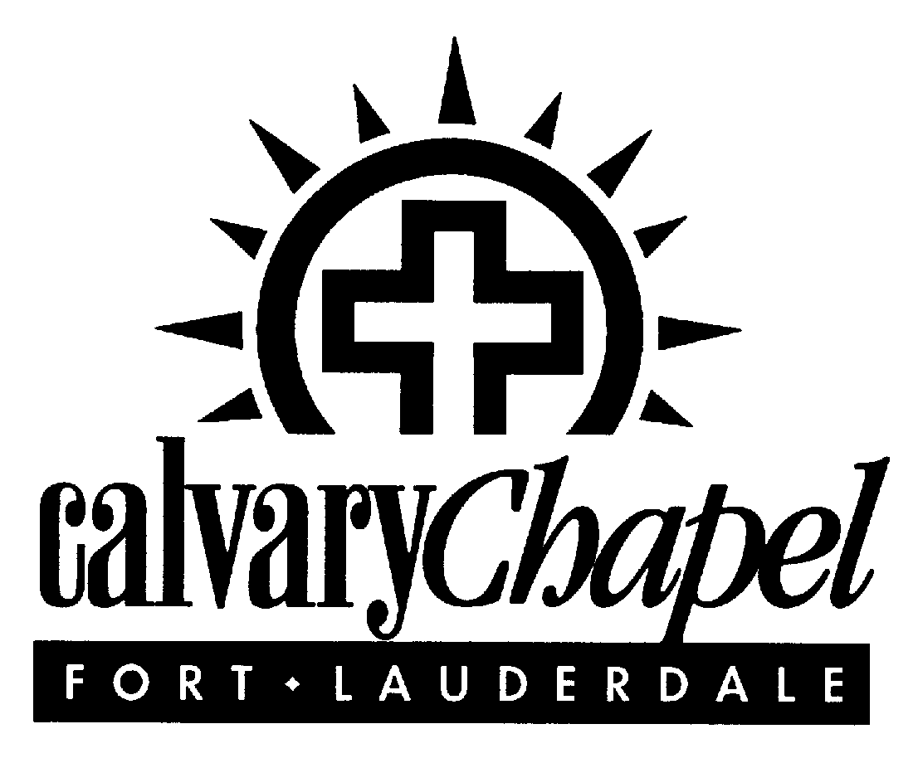”
Ephesians 2:10

WELCOME!
It was years ago when I first heard this verse taught by my Senior Pastor, Chuck Smith. With a sense of awe and adventure, I realized that I was truly a part of God’s wonderful plan. Over the years, one of the greatest parts of my adventure in faith has been the discovery of who I am in Christ, the fulfillment of my call, and the unending excitement that does not want to miss anything God has in store for me.

As an employee of Calvary Chapel, you also have been called to the adventure of God’s plans for South Florida. You will discover, as I have, that this call permeates not just your public ministry and position here on staff, but even your private life. You will be known and seen around town as one of those “on staff,” and with this realization you will sense the serious responsibility to which you have been called. God has entrusted you with the high call and privilege of being a right reflection of Him in this ministry. It is His church and His reputation that hang in the balance. So I would admonish you with the apostle Paul’s own words:

“…Whatever you do, do it heartily, as to the Lord and not to men, knowing that from the Lord you will receive the reward of the inheritance; for you serve the Lord Christ.” Colossians 3:23-24

You will also discover, as I have, that His grace is more than sufficient to empower you to display a biblical, spiritual, and ethical walk whether you are functioning in your role here at church or enjoying time off with your family and friends at home and in the community. So, let me encourage you to strive toward living a life that is an example to others of your faith. I look forward to seeing you experience the same excitement and joy that I have in watching God’s plans for my life unfold each day as I simply walk in obedience to His Spirit.

“I say then: ‘Walk in the Spirit, and you shall not fulfill the lust of the flesh.’”
Galatians 5:16

Till The Whole World Hears,



PASTOR BOB COY

Senior Pastor

RJC/mwd

SECTION I – INTRODUCTION

“For we are His workmanship, created in Christ Jesus for good works, which God prepared beforehand that we should walk in them.” Ephesians 2:10

MISSION STATEMENT
Calvary Chapel is a fellowship of believers in Jesus Christ who are called to go and “make disciples” through teaching the Word, worship, fellowship, and evangelism.

"Go therefore and make disciples of all the nations, baptizing them in the name of the Father and of the Son and of the Holy Spirit, teaching them to observe all things that I have commanded you; and lo, I am with you always, even to the end of the age." Matthew 28:19-20

We believe that each Calvary Chapel staff member has been called by God to also fulfill the Great Commission that involves spreading the gospel in practical application through doing church well, outreach, in-reach, and stewardship. Practically, this means orchestrating the biblical format of church in such excellence that it allows the body of Christ to enjoy the presence of God in worship, the fellowship of God in the teaching of His Word, and the power of God in the release of His Spirit for salvation. As the body of Christ grows and matures through church attendance, our secondary focus becomes outreach, in-reach, and stewardship, which accompany a healthy church life.
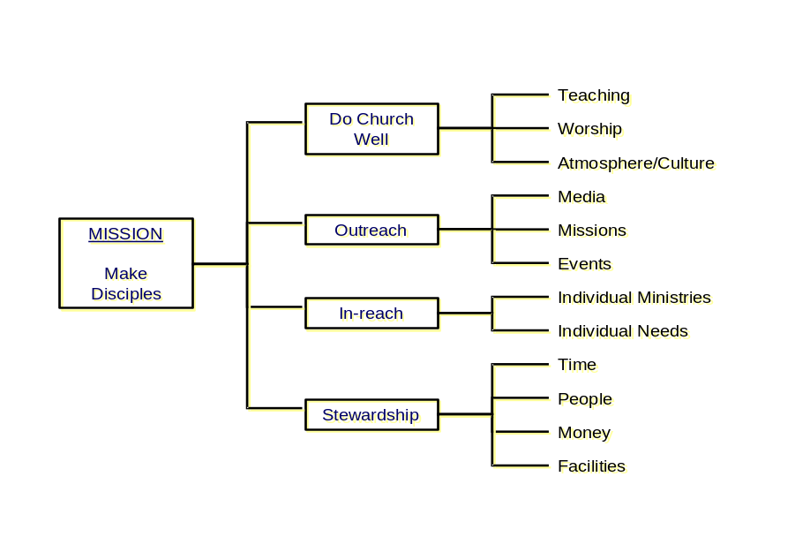

BRIEF HISTORY OF CALVARY CHAPEL
Calvary Chapel Fort Lauderdale follows the philosophy of Calvary Chapel Costa Mesa, pastored by Chuck Smith. Pastor Chuck founded Calvary Chapel in the late 1960s in a time when most traditional churches were turning away the next generation because of the length of their hair and the counterculture lifestyle that they practiced. Driven by a burden for that generation, Pastor Chuck reached out to them with love and understanding and without compromise of Christian principles. A result of this outreach was the birthing of the “Jesus Movement.”

More than thirty years later, with some 932 planted churches ministering to approximately 400,000 people, Calvary Chapels are still reaching out to the lost and attempting to love the unlovable. They are best known for their strong emphasis on the teaching of God’s Word and the application of the Word to everyday life. High importance is also placed upon worship, which consists of contemporary style music designed to put believers in a place of intimate communion with God and to ready their hearts for the teaching of His Word.

Having enjoyed the simple philosophy of Calvary Chapel Costa Mesa, Pastor Bob Coy and his wife, Diane, moved to Fort Lauderdale in 1985, in response to a calling of God’s Spirit to South Florida. After arriving in an area saturated with churches and being told that Fort Lauderdale did not need any more churches, they purposed to faithfully minister in the Calvary Chapel style, teaching the Word of God and reaching out to the lost.

Pastor Bob and Diane have had the privilege of watching God honor His call in their lives as Calvary Chapel Fort Lauderdale has become a growing church of believers filled with God’s Spirit, a hunger and thirst for God’s Word, and a love for the lost. The Lord has truly blessed Calvary Chapel Fort Lauderdale more than anyone could ever have asked, hoped for, or imagined. Today, it is a vibrant and healthy part of the body of Christ with more than 70 ministries for children, youth, and adults. Over 15,000 adults participate weekly in the weekend and mid-week Bible studies, and over 2,500 children and youth learn the Word of God through our dynamic Children’s and Youth Ministries. God’s blessings have also included a beautiful 72-acre property located at 2401 West Cypress Creek Road in Fort Lauderdale, which houses two buildings totaling 300,000 square feet. Our most recent addition to the ministry is Calvary Christian Academy (CCA). Calvary Christian Academy’s mission is to make disciples through a biblical school environment that prepares students to glorify God spiritually, academically, and socially. CCA ministers to 790 students and their families.

OUR VISION FOR THE FUTURE
No one could have begun to imagine what God would do through the obedience of one couple to the call of Christ in their lives. Yet, even in the face of unbelievable growth, the heart of our Senior Pastor and his team of Assistant Pastors still seek the millions of lost sheep in South Florida. It is their heartfelt commitment to continue making disciples until every person living in the tri-county area in which we minister enters God’s kingdom and is serving Him to his or her full capacity.

As well, the Pastors have realized that God’s purposes and plans for this church will not stop with those who can be housed within our four walls. Through the modern technology of audio, video, and Internet capabilities, we will be able to touch the lives of millions of souls with the gospel of Jesus Christ! Whether within the four walls of Calvary, through community outreach, or through media evangelism, our vision is to continue to make disciples!

The fulfillment of our ministry is to teach the Word without compromise, for it is by the Word that disciples are won, and it is by the Word that they are trained and equipped to do the work of the ministry that the body of Christ will be encouraged to endure until the end. The Pastoral team is convinced that we, as a generation, may be living in the last days before Christ’s return. We consider it to be a high call and privilege that are accompanied by a serious responsibility. The Bible has given us our charge for this season in which live:

“I charge you therefore before God and the Lord Jesus Christ, who will judge the living and the dead at His appearing and His kingdom: Preach the word! Be ready in season and out of season. Convince, rebuke, exhort, with all longsuffering and teaching. For the time will come when they will not endure sound doctrine, but according to their own desires, because they have itching ears, they will heap up for themselves teachers; and they will turn their ears away from the truth, and be turned aside to fables. But you be watchful in all things, endure afflictions, do the work of an evangelist, fulfill your ministry.” 2 Timothy 4:1-5

STATEMENT OF FAITH
Calvary Chapel has been formed as a fellowship of believers in the Lordship of Jesus Christ. Our supreme desire is to know Christ and be conformed to His image by the power of the Holy Spirit. We are not a denominational church, nor are we opposed to denominations as such, only to their overemphasis of the doctrinal differences that have led to the division of the body of Christ.

The following is Calvary Chapel Fort Lauderdale’s Statement of Faith:

Doctrinal
We believe that the Bible is God’s supernatural, holy Word to mankind and that:

“All Scripture is given by inspiration of God, and is profitable for doctrine, for reproof, for correction, for instruction in righteousness, that the man of God may be complete, thoroughly equipped for every good work.” 2 Timothy 3:16-17

For that reason, we have found the following statements of faith to be Bible-based truth upon which this ministry functions:

- We believe there is one living and true God, eternally existing in three persons: the Father, the Son, and the Holy Spirit, equal in power and glory; that this triune God created all, upholds all, and governs all.
- We believe in God, the Father, an infinite, personal Spirit, perfect in holiness, wisdom, power, and love; that He concerns Himself mercifully in the affairs of men; that He hears and answers prayer; and that He saves from sin and death all who come to Him through Jesus Christ.
- We believe in Jesus Christ, God’s only begotten Son, conceived by the Holy Spirit. We believe in His virgin birth, sinless life, miracles, and teachings; His substitutionary atoning death; bodily resurrection; ascension into heaven; perpetual intercession for His people; and personal, visible return to earth. We believe that He is one and the same as God. He was fully human and fully God.
- We believe in the Holy Spirit, who came forth from the Father and Son to convict the world of sin, righteousness, and judgment and to regenerate, sanctify, and empower in ministry all who believe in Christ. We believe the Holy Spirit indwells every believer in Jesus Christ and that He is an abiding Helper, Teacher, and Guide. We believe that Jesus Christ baptizes the seeking believer with the Holy Spirit and power for service, either at the time of or subsequent to regeneration, which is a separate work from the indwelling Spirit for salvation. We believe in the present ministry of the Holy Spirit and in the exercise of all biblical gifts of the Spirit as reflected through the fruit of that same Spirit.
- We believe that all the Scriptures of the Old and New Testaments are the Word of God, fully inspired and without error in the original manuscripts, and that they are the infallible rule of faith and practice.
- We believe all people are by nature separated from God and responsible for their own sin, but that salvation, redemption, and forgiveness are freely offered to all by the grace of our Lord Jesus Christ. When a person repents of sin and accepts Jesus Christ as his/her personal Lord and Savior, trusting Him to save, that person is immediately born again and sealed by the Holy Spirit, all of his/her sins are forgiven, and that person becomes a child of God, destined to spend eternity with the Lord.
- We await the pre-tribulation rapture of the church, and we believe in the literal Second Coming of Christ with His saints to rule the earth, which will be personal and visible. This motivates us to holy living, heartfelt worship, committed service, diligent study of God’s Word, regular fellowship, participation in adult baptism by immersion, and Holy Communion.
- We believe in the universal Church, the living, spiritual body, of which Christ is the head and all regenerated persons are members.
- We believe the Lord Jesus Christ committed two ordinances to the Church: 1) baptism, and 2) the Lord’s Supper. We believe in baptism by immersion and communion, both of which are open to all believers in Jesus Christ.
- We believe in the laying on of hands for the sending out of pastors and missionaries, and in conjunction with the anointing of oil by the elders for the healing of the sick.
- We are neither Five-Point Calvinists, nor are we Arminians. We adhere firmly to the biblical teaching of God’s sovereignty and man’s responsibility. We avoid any theological systems of belief that go beyond the written Word and thereby divide the body of Christ.
- We do not believe in “positive confession” (the faith movement belief that God can be commanded to heal or work miracles according to man’s will); human prophecy that supersedes the Scriptures; the incorporation of humanistic and secular psychology into biblical teaching; the overemphasis of spiritual gifts and experiential signs and wonders to the exclusion of biblical teaching; or that true Christians can be demon-possessed.

Practical
- We believe the only true basis of Christian fellowship is Christ’s agape love, which is greater than differences we possess, and without which we have no right to claim ourselves Christians.
- We believe worship of God should be spiritual; therefore, we remain flexible and yielded to the leading of the Holy Spirit to direct our worship.
- We believe worship of God should be inspirational; therefore, we give great place to music in our worship.
- We believe worship of God should be intelligent; therefore, our services are designed with great emphasis upon the teaching of the Word of God that He might instruct us on how He should be worshiped. We seek to teach the Word of God in such a way that its message can be applied to the individual’s life, leading that person to a greater maturity in Christ. We teach both expositionally and topically.
- We believe worship of God should be fruitful; therefore, we look for His love in our lives as the supreme manifestation that we have been truly worshiping Him.
- We believe that the church government should be simplistic rather than a complex bureaucracy, and we depend on the Holy Spirit to lead, rather than on fleshly promotion.
- We believe that the Bible clearly delineates that spiritual gifts are for the edification of the body and that they are to be exercised in love. We believe that love is more important than the most spectacular gifts, and without love, all exercise of spiritual gifts is worthless. In our services, we focus on a personal relationship with God through worship, prayer, and the teaching of the Word of God. We do not practice speaking in tongues during worship or while a Bible study is in progress because we do not believe that the Holy Spirit would interrupt Himself. God is not the author of confusion. These gifts are encouraged in more intimate settings, e.g. afterglow services and small groups where their benefit can accomplish the purpose for which they have been given – the edification of the body of Christ.

LEADERSHIP
Leadership consists of those called to serve in the ministry of Calvary Chapel and is comprised of the Board of Directors, Pastors, Ministers, Staff, Elders, Deacons / Deaconesses, and Team Members.

Board Of Directors
Calvary Chapel Church, Inc. is organized in the State of Florida as a non-profit corporation. It has been recognized and approved as a 501(c)(3) corporation by the Internal Revenue Service. It is governed by a Board of Directors that meets quarterly to review the ministry goals and vision as well as the financial operations of the ministry. The Board approves an annual budget with broad guidelines for ministry areas and specific line-item approvals for capital expenditures and all real estate transactions. The Pastors are given operational authority within those guidelines and approvals to run the ministry on a daily basis.

Within the Board there is also a Compensation Committee that meets annually and as needed to handle specific decisions related to staff salaries and benefits. This committee, made up of four non-staff board members plus the Senior Pastor and the Church Administrator, reviews all staff members annually. The staff members of this committee remove themselves from any discussion involving their own salaries or benefits.

Pastors
Pastors are seasoned men of God called to a position of spiritual leadership and ministry management here at Calvary Chapel. The Pastors of the church and a few other key individuals meet weekly to review all aspects of the ministry. Each Pastor is responsible for specific areas of ministry oversight and reports to the Senior Pastor. The Pastors’ meetings are controlled by an agenda and are characterized by prayer, discussion, and decisions in a consensus style of management. Each Pastor is encouraged to share his own thoughts on any subject, and the decision-making is a strong team-approach that functions very well. Though it can be time-consuming to operate with a consensus style of management with the Senior Pastor as the leader, it has proven very effective at governing the church in a style where there is teamwork, cooperation, and a spirit of unity with every area aware of the other areas of ministry. The Pastors review monthly financial reports and make appropriate decisions within the Board-approved guidelines.

Ministers
There are Ministers on staff who serve under the Pastors and function in a narrower area of specialization within the ministry. The Ministers are equipped to teach, counsel, and perform other ministry functions such as weddings, funerals, hospital visits, emergency counseling calls, etc. The Ministers meet with their respective Pastors in their areas of oversight on a consistent basis.

Staff
The church employs over 280 staff members. In addition to the Pastors and Ministers, there are a variety of positions such as support, managerial, administrative, technical, service, and school staff. The staff is supervised by the Pastors responsible for their respective areas of ministry. The entire staff meets once a month for prayer, devotionals, and informational updates on the ministry. As all employees represent this ministry in both their work and private life, they are expected to uphold the standards of a Christian according to the New Testament guidelines, striving to live a life above reproach.

Elders
Elders are men who have been tested and found faithful to serve at Calvary Chapel in the role of overseer. Their basic function is to have a keen oversight of the spiritual soundness of the body. Each man is able to determine false doctrine, correct it, rebuke those who disseminate it, and replace it with sound doctrine. First Timothy 3:2-3 defines an Elder as an overseer who must be …”blameless, the husband of one wife, temperate, sober-minded, of good behavior, hospitable, able to teach; not given to wine, not violent, not greedy for money, but gentle, not quarrelsome, not covetous” (I Timothy 3:2-3). He must manage his own family well and see that his children obey him with proper respect. He must not be new to the faith, and he must also have a good reputation with outsiders. It is noteworthy to mention that of the 19 biblical requirements, 17 pertain to his character and two specifically deal with Bible knowledge. These leaders meet once a month.

Deacons / Deaconesses
There are also Deacons and Deaconesses who serve at Calvary Chapel. Their basic function as leaders within the church is to be considerate of the physical needs in the body of Christ, as we see from the account in Acts 6. First Timothy 3:8-12 defines Deacons as leaders who “must be reverent, not double-tongued, not given to much wine, not greedy for money, holding the mystery of the faith with a pure conscience. But let these also first be tested; then let them serve as deacons, being found blameless. Likewise their wives must be reverent, not slanderers, temperate, faithful in all things. Let deacons be the husbands of one wife, ruling their children and their own houses well” (1 Timothy 3:8-12).

The major difference between an Elder and a Deacon is in the area of teaching. However, in his character and commitment, the Deacon is held to a similar standard as an Elder. Although a Deacon finds himself many times ministering to the temporal needs of the body of Christ, he must do so in the Spirit of Christ. He is involved in one of many areas of ministry. The Deacons and Deaconesses meet once a month for an update and review of the ministry plans.

Team Members
Webster’s Dictionary defines a Team as a group of people working or playing together. A Team Member is a part of the body of Christ who does not fit into the category of Elder or Deacon but upon whose shoulders falls a great deal of the orchestration of what happens in the church. In reviewing the biblical roles of Elder and Deacon, it is easy to recognize that many people who serve in the body of Christ do not fall into either category. We term this third category of soldiers “Team Members.” In addition to these soldiers, staff who are not an elder, deacon, or deaconess are also considered “Team Members.”

You may identify with the position of a Team Member as we look at their function through the use of the word TEAM as an acronym:

T = TESTED. Team Members are those who have been tested in ministry and found faithful. They serve only for the sake of Christ. They have not fallen to the temptation of the enemy in the area of pride. Whether they are recognized, appreciated, misunderstood, or even offended, their service continues undauntingly. In the fire of testing, their motivation has remained pure and they have passed the test of love, which overlooks all offenses.

E = EFFECTIVE. Team Members not only serve in ministry, but their efforts are effective. The fruit of their labor testifies that they are connected to the Vine.

A = ACTIVE. Team Members are those whose faces are easily recognizable because they are seen everywhere. They enjoy the fellowship of the saints, and their priorities to serve the body of Christ are evident to all. While maintaining a proper balance between ministry and family, they have streamlined their lifestyle to include those things of eternal value and are therefore available for active duty.

M = MINISTER. Team Members are ministers. They are other-centered individuals who have learned the scriptural mandate of esteeming others more highly than themselves. They are ministers in the miraculous as well as the mundane. Whether they encounter a tearful single mom or an irate customer at their place of business, they see every opportunity as a chance to do what Jesus would do.

Volunteers
There are countless other volunteers who faithfully and regularly serve Calvary Chapel. Their basic function is to serve in any capacity or wherever there is a need in the body of Christ. These individuals must complete a Ministry Questionnaire in order to be eligible to volunteer and serve. These individuals are very important to Calvary Chapel because they sacrifice their time, gifts, talents, and resources. Our Lord and Savior Jesus Christ is the perfect example of a servant, and we, the body of Christ, are called to serve one another as He commanded, according to John 13:15. Because not all volunteers are considered leadership of the church, volunteers who are not a Minister, Elder, Deacon (ness), or Team Member are not required to attend the mandatory leadership meetings.

OUTSIDE AFFILIATIONS
Calvary Chapel follows the philosophy and the Statement of Faith of Calvary Chapel Outreach Fellowships based in Costa Mesa, California, which is the location of the first Calvary Chapel, pastored by Chuck Smith. Calvary Chapel of Costa Mesa has birthed hundreds of churches across the United States and overseas and has a complete Christian school, Bible college, retreat and conference center, and overseas missions training facilities. It is well known for its national radio ministry called “The Word For Today.” Calvary Chapel is responsible for ministries that impact the entire world.

There are numerous Calvary Chapels that have more than 5,000 members, and those large Calvary Chapels continue as some of the fastest growing churches in the country. According to Dr. John Vaughan who studies church growth and publishes national statistics on this subject, Calvary Chapel Fort Lauderdale has been in the top twenty fastest growing churches in the country every year for the past five years. Currently, there are over 35 Calvary Chapels in Florida, and 932 Calvary Chapels worldwide. These churches participate in regional and national pastors’ conferences, worship conferences, and youth ministry conferences on an annual basis.

SECTION 2 – EMPLOYMENT

“And whatever you do, do it heartily, as to the Lord and not to men, knowing that from the Lord you will receive the reward of the inheritance; for you serve the Lord Christ. But he who does wrong will be repaid for what he has done, and there is no partiality.” Colossians 3:23-25

INTRODUCTORY STATEMENT
This handbook applies to all employees and is intended to provide standards and summary information concerning personnel policies, procedures, benefits, and rules of conduct. The Employee Handbook is the property of Calvary Chapel Church, Inc. Its contents are confidential and should not be shared or disseminated outside the workplace unless authorized by the Church Administrator.

This is not a contract and can be changed in whole or in part at any time or as any specific situation may require. It is important that you read, understand, and become familiar with the Employee Handbook and comply with the standards that have been established. Please talk with your supervisor or Human Resources Department if you have any questions, need clarification, or need additional information.

It is obviously not possible to anticipate every situation that may arise in the workplace or to provide information that answers every possible question. As a result, the church reserves the right to modify, supplement, rescind, or revise any policy, benefit, or provision from time to time, with or without notice, as it deems necessary or appropriate. When applicable, revisions, changes, and/or updates may be communicated to the employees via an addendum.

If there is a conflict between the provisions, benefits, and policies in this Employee Handbook and those set forth in the terms of a staff member’s written employment agreement, the terms of that agreement shall prevail.

All references to the Church, Calvary Chapel, or Calvary Chapel Fort Lauderdale shall refer to Calvary Chapel Church, Inc., its integrated auxiliaries and supporting organizations, affiliates, and controlled entities, unless otherwise designated within this policy.

Types / Classifications

EMPLOYMENT-AT-WILL
Employment is with the mutual consent of the employee and the church. Consequently, both the employee and the church have the right to terminate the employment relationship at any time, with or without cause or advance notice. This employment-at-will relationship will remain in effect throughout each individual’s employment with the church unless it is specifically modified by an express, written agreement approved by the Board of Directors of the church. The church will strive to apply biblical principles to all of its employment policies and decisions.

This employment-at-will relationship may not be modified by any oral or implied agreement.

COMMITMENT TO SIGNED OFFER LETTERS
Offer letters are given to potential employees of the church in order to offer a position either with the church or the school. This offer letter is not considered a contract but a letter of offer as a mutual commitment between the potential employee and the church. This letter outlines the salary expectations, the position being offered, entitled benefits, and the expected start date. In acceptance of the offer, the church recognizes that the potential employee is willing to comply with the policies, procedures, and conduct expected and that in doing so, the church agrees to employ the applicant. Offer letters given to potential employees of the school are intended for the academic year. However, if the school employee is terminated for any reason before the end of the school year, the church will pay only the portion of the salary for the time worked.

EQUAL EMPLOYMENT OPPORTUNITY
The church is committed to providing equal employment opportunity to all qualified persons without regard to their race, color, ancestry, national origin, sex, marital status, disability, or age. Further, the church is committed to accommodating persons who have disabilities who wish to serve. To deny a qualified person the chance to contribute to the ministries of Calvary Chapel because he or she is a member of a minority group is unfair to everyone and is not consistent with Scriptural principles.

Calvary Chapel does reserve the right to employ persons who have a spiritual background and philosophy of ministry similar to ours and who, in the opinion of the church, have a work history and a lifestyle that is consistent with Scriptural principles. All employment decisions will be made in compliance with applicable labor laws, which do not contradict Scriptural mandates.

We expect all employees to show respect and sensitivity toward all other employees and to demonstrate a commitment to the church’s equal employment opportunity objectives. If an employee observes a violation of this policy, he/she should report it immediately to his/her supervisor or the Human Resources Department. Violation of this policy may result in disciplinary action, up to and including possible termination.

IMMIGRATION LAW COMPLIANCE
The church is committed to employing United States Citizens and aliens who are authorized to work in the United States and does not unlawfully discriminate on the basis of citizenship or national origin.

In compliance with the Immigration Reform and Control Act of 1986, each new employee, as a condition of employment, must complete the Employment Eligibility Verification Form I-9 and present documentation establishing identity and employment eligibility. Copies of the documentation will be retained in a separate file apart from the employee’s personnel file.

EMPLOYMENT OF MINORS
The employment of minors (under 18 years old) is restricted to certain terms and conditions of the Work Permit (if applicable) and the provisions of state and federal law. A copy of these terms and conditions is displayed on the Human Resources Department bulletin boards.

EMPLOYMENT OF RELATIVES
Relatives of employees will receive the same consideration as any other applicant for a job opening and will not be given preferential treatment in employment matters. However, related employees might not be permitted to work in the same department or under the direct supervision of each other because of employee morale, security, or other legitimate business reasons. In addition, the church may require a related employee to transfer or resign if there is a conflict of interest or management problem of supervision that cannot be resolved. The choice as to which employee must resign would be the sole discretion of the church and cannot be construed to constitute a violation of the Equal Employment Opportunity policy found in this Employee Handbook.

EMPLOYMENT SCREENING: DRUG TESTING/ BACKGROUND CHECKS / REFERENCE CHECKS
As a condition of employment, the church will screen each applicant and employee in the following areas:
    - Drug Testing: All approved applicants will be required to complete a drug test done at a local medical research laboratory.
    - Background Checks: All approved applicants will have a complete criminal history background check from the church. This will include fingerprinting, which will be given to the local, state, and federal law enforcement agencies.
    - Reference Checks: All applicants will receive a minimum of three (3) reference checks. These will include but may not be limited to personal, professional, and spiritual checks from family, friends, and previous employers.

NEW HIRE ORIENTATION
New Hire Orientation is an opportunity to give new employees important information about the church, employee benefits, policies and procedures, staff expectations, some basic technical training in computers, phones, equipment, and other pertinent information to aid in successfully bringing a new hire on staff. The Human Resources Department works with various departments to bring this information to all new hires on a regular basis. The New Hire Orientation also includes devotions from various Pastors, which provide an opportunity for fellowship and spiritual encouragement.

FORMER EMPLOYMENT REFERENCES
No employee of the church is authorized to provide job references to prospective employers of former church employees. If an employee receives a request for such a reference, he/she must direct it to the Human Resources Department.

EMPLOYEE STATEMENT OF ACKNOWLEDGMENT
Upon completion of the New Hire Orientation process, each new employee will submit to the Human Resources Department a signed and dated Employee Statement of Acknowledgment. This signed acknowledgment states that the employee has received a copy of the church’s Employee Handbook, has read and understands it, and will comply with the standards set forth in it. See Exhibit A “Employee Statement of Acknowledgement” form.

EMPLOYMENT CLASSIFICATIONS
The church classifies its employees as follows:

Full-time Employee
Full-time (FT) employees work a minimum of 35 hours per workweek.

Part-time Employee
Part-time (PT) employees work less than 35 hours per workweek.

Salaried Employee
Full-time salaried employees are expected to work at least forty (40) hours per week.

Hourly Employee
Hourly employees will be paid for all hours worked and such hours must be recorded in accordance with all time-keeping policies in effect. Employees covered by the Fair Standards Labor Act (FLSA) will be paid in accordance with applicable requirements.

Temporary Employee
Temporary employees are hired for a specific period of time or a specific project or event that will result in their employment ending upon completion. Temporary employees will not be included in various staff meetings and events and are not eligible for employee benefits.

Pastoral / Ministerial

Pastoral Staff
Pastoral employees consist of men who have been ordained as Pastors and serve in a broader range of spiritual oversight and responsibility for the whole church body under the leadership of the Senior Pastor.

Ordained Ministerial Staff
Ministerial employees consist of men who are ordained Ministers who serve in a specific area in either a ministerial or managerial role under the oversight of a Pastor.

Support Staff

Non-Ordained Ministerial Staff
Ministerial employees consist of non-ordained Ministers and/or Ministry Assistants who serve in a specific area of ministry, either in an administrative, managerial, or ministerial role, under the oversight of a Pastor, Minister, or Manager.

Managerial Staff
Managerial employees consist of those individuals who serve as a Director, Manager, or Department Supervisor where supervision of support staff may be required.

Administrative Staff
Administrative employees consist of those individuals who serve in either a support or an administrative role under the oversight of a Pastor, Minister, or Manager.

Technical Staff
Technical Support employees consist of those individuals who serve in a technical function and have a specific education, a license, or experience in their field.

Service Staff
Service employees consist of those individuals who serve in a service function including customer service, food service, and/or maintenance of the facility.

Calvary Christian Academy Staff

Administration
Administration employees consist of the Principal, the Assistant Principals, the Chaplain/Athletic Director, and other employees in full-time Director / Advisor positions.

Administrative Staff
Administrative employees consist of those individuals who assist in the office as Administrative Assistants, Receptionists, or other support roles.

Teachers
Teachers consist of those individuals who are responsible for the entire operation and functioning of the classroom including teaching, discipling, mentoring, classroom management, student assessment, and the overall care of the children.

Teachers’ Assistants
Teachers’ Assistants consist of those individuals who work directly with the Teachers in the classrooms. They are responsible for supporting the Teacher in any capacity for the overall functioning of the classroom as well as anticipating additional needs for the students and the Teachers as they arise.

After School Staff
After School employees consist of those individuals who work in the After School Program teaching, directing, and caring for the children.

BENEFITS

“Do not withhold good from those to whom it is due, When it is in the power of your hand to do so.” Proverbs 3:27

The church’s benefit plan is designed to provide compensated time away from work, to help employees pay certain expenses, to make available cost-effective coverage through group rates to employees’ eligible dependents, and to provide certain other assistance as occurrences arise.

Included in the benefits are numerous types of days off. Exhibit B is a copy of the “Request For Time Off” form that an employee is required to complete when requesting any time off. Exhibit C is a copy of the “Substitute Report and Sign-In” form used for Teachers and Teachers’ Assistants when requesting time off. The employee must complete the appropriate form in advance and turn it in to his/her supervisor. The submission of this request does not guarantee approved time off for the specific dates requested. All requests will be given equal consideration and be determined based upon eligibility and then priority received, seniority, and staff coverage.

VACATION
Requests for vacation time off must be made in writing and should be approved by the employee’s supervisor who will then submit it to Human Resources Department for final approval and documentation. All requests should be submitted at least thirty (30) days in advance. Vacation requests will be approved on a first-come-first-served basis, and only if the time off will not interfere with the normal business operations of the church.

Full-Time Pastoral/Ministerial Employment
All full-time ordained Pastoral/Ministerial employees will earn vacation on their anniversary date, based on their length of continuous service with the church, as follows:

Length of Continuous Service Vacation
After 1 Year 5 Days
After 2 through 5 Years 10 Days
After 5 through 15 Years 15 Days
After 15 Years or More 20 Days

Full-Time Employment
All other full-time employees will earn vacation on their anniversary date, based on their length of continuous service with the church, as follows:

Length of Continuous Service Vacation
After 1 Year 5 Days
After 2 through 10 Years 10 Days
After 10 through 20 Years 15 Days

Part-Time Employment
All part-time employees will earn vacation on their anniversary date, based on their length of continuous service with the church, as follows:

Length of Continuous Service Vacation
Less than 2 Years 0 Days
After 2 Years or More Average hours of an average workweek

Calvary Christian Academy Staff
All school employees will earn vacation based on their role in accordance with the school’s annual work calendars.

An employee’s anniversary date corresponds to the month and day the employee was hired, subject to adjustment for the portion of any leave of absence in excess of thirty (30) days.

VACATION ACCRUAL POLICY
Employees are encouraged to use all vacation days during the 12-month period after it has been earned. However, in the case that an employee accrues more than 4 weeks of vacation time, the employee will have the option to either receive pay for that earned vacation time or use their vacation time before accruing more vacation time. Note: This policy is effective upon receipt of this handbook and is not retroactive.

Full time employees who are terminated without cause and employees who resign without providing a minimum of two (2) weeks notice will receive accrued vacation pay at their then current rate of pay. Under rare circumstances, with Pastoral approval, the church may grant approval of vacation requests prior to being earned.

HOLIDAY PAY
All church employees will be eligible on the first day of the calendar month following the completion of thirty (30) days of continuous employment to receive holiday pay.

New Years Day- January Thanksgiving Day- November
Day After Easter- April Day After Thanksgiving- November
Memorial Day- May Christmas Day- December
Independence Day- July Day After Christmas- December
Labor Day- September

In addition to the above nine (9) paid holidays, all full-time staff will be entitled to a “Floating Holiday” to be selected by the employee and included as part of the ten (10) paid holidays that occur during each calendar year. An example of a “Floating Holiday” would be: Martin Luther King’s Birthday, Presidents’ Day, Veterans Day, employee’s own birthday, or a Sabbath day.

Full-time salaried employees who work on the above listed holidays will be paid their normal salary if the holiday falls on their normally scheduled day off. In addition, they are able to save the holiday as a “Holiday Trade Day” to be used at another time within six months of the date earned. Employees using a “Holiday Trade Day” must note the holiday they are trading on the “Request For Time Off” form. See Exhibit B for “Request For Time Off” form.

Full-time hourly employees who work on the above listed holidays will be compensated for 8 hours of the holiday and any actual hours worked on that day. Hourly employees are not eligible for “Holiday Trade Days.”

Part-time employees will be eligible for holiday pay only when the holiday falls on a regularly scheduled workday and will be compensated for their normally scheduled hours.

All school employees will be eligible for holiday pay based on their role in accordance with the school’s annual work calendars.

Other General Information Related to Holiday Pay
- Holidays will be observed on the calendar day designated by the church.
- If a holiday falls during an employee’s approved vacation period, the employee will receive holiday pay and will not be charged for a vacation day on the day the holiday is observed.
- Employees on leave of absence for any reason are not eligible for holiday pay on holidays that are observed during the period they are on leave.
- Employees will not be paid for unused “Holiday Trade Days” or their unused “Floating Holiday” upon termination.

LEAVES OF ABSENCE
A leave of absence is a period of time up to twelve (12) weeks that is requested for reasons that may be personal, medical, or family.

The church makes leaves of absence available to employees as follows with these general provisions:

- All leaves of absence must be submitted in advance in writing for approval on a “Request For Time Off” form to the Church Administrator. See Exhibit B for “Request for Time Off” form.
- A request for an extension of a leave of absence must be made in writing prior to the expiration date of the original leave and, when appropriate, must be accompanied by a physician’s written statement that certifies the need for the extension.
- If a leave of absence is extended for a period of twelve (12) weeks or longer, an employee may be required to resubmit to a drug test before returning to work.
- Employees on leave of absence must communicate with the church on a regular basis, at least once each month, regarding their status and anticipated return date.
- An employee must return to work on the first workday following the expiration of an approved leave. If he/she fails to report to work, or to call, for two (2) consecutive workdays after the approved return date of the leave, he/she may be considered to have voluntarily resigned.
- Coverage under the church’s group insurance plans will be continued on the following basis:
    - Employees must make arrangements with Calvary Chapel to pre-pay their share of group insurance premiums before going on leave of absence.
    - For the first thirty (30) days of an approved leave of absence, the church will continue to contribute to premiums as if the employee was actively at work;
    - With the exception of employees on the Family and Medical Leave, employees will be required to pay the entire premium for continued coverage during the portion of an approved leave of absence in excess of thirty (30) days.
- Employees will not accrue length of continuous service for the portion of a leave of absence in excess of thirty (30) days.
- Employees on leave of absence will be subject to layoff on the same basis as employees who are actively at work.
- Employees on leave of absence who seek or accept other employment without the church’s prior written approval will be subject to disciplinary action, up to and including possible termination.
- Employees who falsify the reason for their leave of absence will be subject to disciplinary action, up to and including possible termination.

Family and Medical Leave
Employees are eligible for Family and Medical Leave if they have worked for the church at least one (1) year, and for 1,250 hours over the previous twelve (12) months. Eligible employees may take up to twelve (12) weeks of unpaid leave for certain family and medical reasons.

Unpaid leave will be granted for any of the following reasons:

- To care for the employee’s child after birth or as a result of adoption or foster care;
- To care for the employee’s spouse, son or daughter, or parent, who has a serious health condition;
- For a serious health condition that makes the employee unable to perform his or her job.

At the employee or employer’s option, certain kinds of paid leave may be substituted for unpaid leave if eligible for paid leave.

Advance Notice and Medical Certification
The employee may be required to provide thirty (30) days advance leave notice and medical certification. Taking of leave may be denied if requirements are not met. The employee ordinarily must provide thirty (30) days advance notice when the leave is “foreseeable.” The church may require medical certification to support a request for leave because of a serious health condition and may require second or third opinions (at the employer’s expense) and a fitness for duty report to return to work.

Job Benefits Protection
For the duration of the Family and Medical Leave, the employer will maintain the employee’s coverage under any “group health plan” at the level and under the conditions that coverage would have been provided if the employee had continued to be employed continuously during leave. Upon return from Family and Medical Leave, most employees will be returned to their original or equivalent positions with equivalent pay, benefits, and other employment terms. The use of Family and Medical Leave will not result in the loss of any employment benefit that accrued prior to the start of an employee’s leave.

Personal Leave
All full-time employees who have completed at least three (3) years of continuous service may be eligible for a personal leave of absence, without pay, for any length of time up to a maximum of (12) twelve weeks. Written requests must state the reason for the leave as well as the beginning and ending dates. Some examples of unpaid personal leave are:
- Compelling personal reason not medically related
- Extended missions trip
- Sabbatical to further personal, spiritual, or professional growth and well-being.

Requests for personal leave will be granted at the sole discretion of the Pastors, based on the facts and circumstances surrounding each individual request.

Employees who return to work at the end of a personal leave will normally be returned to their former job classification if an opening exists or, if there is no such opening, they will be considered for a comparable position if one is available.

Jury Duty
Jury Duty is a leave of absence to serve on jury duty. Upon completion of jury duty, a “Verification of Attendance” Form must be presented to the Human Resources Department. Employees who are excused from jury duty for the day, or who are excused early, should report to work when it is practical to do so. If an employee is called to serve on jury duty at a time that would unreasonably interfere with normal business operations, the Pastoral Overseer of the ministry may request that the required service be rescheduled for a later date that would be more convenient for the ministry.

Military Leave
Military Leave is a leave of absence for required military service. The church complies with applicable state and federal laws concerning leaves for military service.

Workers Compensation Leave
Workers’ Compensation leave is an absence for a work-related illness or injury. The church complies with applicable state and federal laws concerning leaves for work-related illness or injury. The Workers Compensation Information Policy will be distributed to each employee at the New Hire Orientation and is available from the Human Resources Department.

SICK DAYS
All full-time church employees who have completed at least one (1) year of continuous full-time service will be eligible for three (3) paid sick days on their anniversary hire date. Sick days may only be used in the case of personal illness or injury that is not work-related. Work-related illnesses or injuries are covered under Workers Compensation Leave.

Unused sick days may not be used for personal time off or as additional vacation time. Unused sick pay cannot be accrued, and employees will not be paid for unused sick pay benefits upon termination of employment.

Employees may be asked to provide medical verification. Absences of more than three (3) working days may be subject to the church’s leaves of absence policy.

All full-time CCA employees, due to the nature of their work, will receive six (6) days upon their hire date to be used as sick and/or personal days. While six (6) days are granted, no more than three (3) days may be used as personal.

PERSONAL DAYS
All full-time employees who have completed at least one (1) year of continuous full-time service will be eligible for three (3) paid personal days on their anniversary hire date. Personal days are for business, vacation, moving, sickness, anniversaries, funerals, weddings, etc. They may be taken at any time of the year with at least ten (10) days written notice on the “Request for Time Off” form, when appropriate, for scheduling and approval.

Unused personal days must be used within the year earned and cannot be accrued. Employees will not be paid for unused personal days upon termination of employment.

STAFF DEVELOPMENT DAYS
All full-time employees who have completed at least one (1) year of continuous service may be eligible for paid staff development days. Staff development days are available for CCA and other professional or technical staff whose job or ministry may require additional educational or technical training in order to maintain current information or to obtain accreditations. Some examples of staff development days would be educational classes or courses, seminars, and specific job-related or ministry-related conferences (i.e. missions’ conference, administrative assistants’ seminar, etc.)

Request Process:
- Staff development days must be requested thirty (30) days in advance and submitted for approval to the Department Supervisor or Pastoral Overseer.
- The Department Supervisor or Pastoral Overseer will then submit the request to the Human Resources Department for further review and approval. The Human Resources Department will then submit the form for final approval to the Church Administrator.
- The request for days off should be submitted on the appropriate form: the “Request for Time Off” form for Calvary staff and the “Request for Employee Absence and Substitute Assignment” form for CCA staff.
- The “Staff Development Approval – Form A” should also be submitted at the same time as the request for the time off.
- The number of staff development days allowed will be determined in the approval process.
- See Exhibit B for the “Request for Time Off” form and Exhibit C for the “Request for Employee Absence and Substitute Assignment” form. See exhibit D for further information on the “Staff Development Policy and Procedure” and for Staff Development Forms A, B, & C.

MINISTRY DAYS
All full-time employees who have completed at least one (1) year of continuous service may be eligible for ministry days. This category of days off is designed for the employee to learn, grow, and be spiritually fed or to aid in the spiritual growth of others. Some examples of ministry days would be missions trips, retreats, and teaching at seminars or conferences. Ministry days must be requested thirty (30) days in advance and submitted on the “Request For Time Off” form to the Department Supervisor/Pastoral Overseer who will then submit the request to the Human Resources Department for further review and approval. The Human Resources Department will then submit the form for final approval to the Church Administrator. Note: Even if approved, not all ministry days will be paid; each request will be determined on an individual basis in the approval process. See Exhibit B “Request for Time Off” form.

COMP DAYS
Comp days are available for full-time salaried church staff only. This category of days off is for exchanging certain periods of additional or unusual hours worked that are well beyond the normal course of the job requirements that result in a need for time off to balance your schedule and priorities. Comp days will only be granted on a pre-approved basis with at least ten (10) days written notice and are given at the sole discretion of the Department Supervisor/Pastor Overseer and must also have the approval of the Church Administrator.

BEREAVEMENT PAY
Since death is an unexpected event that can occur at any time, the church feels the employee can qualify for this paid absence upon hire date. The church recognizes that a time of bereavement is a very difficult one for an employee. In this regard, every effort will be made to ensure that the employee is able to attend to family matters and is also given the opportunity to minister to others as needed.

All full-time employees will be eligible for up to three (3) days away from work, with pay, to arrange and/or attend the funeral of an immediate family member. Employees who require more than three (3) days away from work may request earned vacation time or a personal leave of absence, subject to the provisions of the church’s leaves of absence policy.

NATURAL DISASTERS EMERGENCY PAY
In the event of a natural disaster or an emergency, the Church Administrator and/or his designees may dismiss employees from their normal work day(s). Pay for these missed days will be determined at the Pastoral level. Once an emergency has been declared, if an employee is designated as an emergency team worker, he/she will be required to report directly to the Administration Office for direction. If it is the employee’s normally scheduled day off, and he/she is required to come in, the employee may request traded time to be given at the discretion of his/her supervisor and will require the approval of the Church Administrator.

Note: In the event of an emergency situation, Calvary Christian Academy will follow the same guidelines as it relates to school closings as directed by the Broward County School District.

INSURANCE
All full-time employees will become eligible for enrollment in the church’s group life, medical, dental, and disability insurance plans on the first day of the calendar month following the completion of thirty (30) days of continuous employment. Employee contributions to the health, dental, and retirement plans are made by payroll deduction. Upon completing the forms, which are part of the New Hire Orientation, the employee’s signature serves as authorization for payroll deductions.

Group Medical Insurance
The church pays 50% of the monthly premium for employee coverage of medical insurance. The church does not participate in dependent coverage; therefore, an employee is responsible for 100% of dependent coverage at his/her option. Detailed information about the plans will be made available at orientation and is also available from the Human Resources Department.

Cobra Insurance
Any employee wishing to continue with his/her health care insurance upon separation from the church is responsible to notify the Payroll and Benefits Administrator of his/her desire to do so within thirty (30) days of separation from the church; the individual is responsible for 100% of the premiums under this continuation policy. Further information is available from the Human Resources Department.

Group Dental Plan
All full-time employees are eligible to participate in the group dental plan. The employee is responsible for paying 100% of the premium. Detailed information about the plan will be made available at New Hire Orientation and is also available from the Human Resources Department.

Group Life / AD&D / Disability Insurance
All full-time employees are eligible for the Group Life / AD&D / Disability insurance plans, which are paid 100% by the church. Further information about the plan will be made available at the New Hire Orientation and is also available from the Human Resources Department.

Workers Compensation Insurance
Workers Compensation Insurance automatically covers all employees at the time of hire. The church pays 100% of the premiums for this important coverage. Some of the benefits of the Workers Compensation Act provided to employees who sustain a work-related injury or illness are:

- Partial wage replacement for periods of disability;
- Medical care, including medicine, hospital, doctor, X-rays, crutches, etc.;
- Rehabilitation services, if necessary.

To ensure Workers Compensation coverage, it is imperative that an employee report ANY work-related injury or illness to his/her supervisor within a 24-hour period, regardless of how minor it may be. The employee will be required to complete an “Incident Report” form and submit to required treatments. Additional Workers Compensation information will be distributed to each employee at the New Hire Orientation and is also available from the Human Resources Department. See Exhibit E for “Incident Injury Report” form.

CAFETERIA PLAN
A Cafeteria Plan has been adopted to enable eligible employees to elect to receive certain group health benefits in lieu of a portion of their compensation. Before the start of each Plan Year, each participant may elect to pay for the cost of his or her coverage under the church’s group health plan paid on a pre-tax basis through payroll deductions under the Cafeteria Plan. The amounts withheld from the participant’s compensation will be paid by the church as part of the premiums for coverage of the participant and/or the participant’s eligible dependents under the group health plan. By choosing to pay for health care coverage through this Plan, a participant can avoid paying federal income taxes or social security taxes on the amount of his or her payments. A Summary Plan Description is available from the Human Resources Department for review by participants.

RETIREMENT PLAN
The purpose of the Plan is to enable participants to save for retirement by deferring the receipt of a portion of their compensation until they retire, to allow the church to make matching contributions to the Plan based on each participant’s deferrals, which will provide the participants with benefits when they retire, or in the case of those who die before retiring, to pay benefits to their survivors.

All full-time employees are eligible to participate in the church’s 403(b) Plan on the first day of the calendar month following the completion of thirty (30) days of continuous employment, and they become eligible for the employer-matching program after the completion of one (1) year from their date of hire. The church matches 50% of an employee’s voluntary contributions up to 3% of the employee’s current salary.

The church reserves the right to change the retirement plan at any time. Further information, a plan summary, and/or enrollment forms will be made available at the New Hire Orientation and are also available from the Human Resources Department.

Educational assistance and professional memberships
Where it can be demonstrated that the church will benefit from an employee’s participation in educational programs or professional organizations and/or conferences, the church may pay the related expenses. Employees should submit their requests on the “Staff Development Approval – From A” to the Department Supervisor who will then submit the request to the Human Resources Department for further review and approval. The Human Resources Department will then submit the form for final approval to the Church Administrator. See Exhibit D for “Staff Development Policy and Procedure” and for Staff Development Forms A, B, & C.

EMPLOYEE DISCOUNTS
Upon hire date, each employee is eligible for various staff discounts. These discounts may include the Bookstore, Tape Ministry, Calvary Christian Academy, and the Bible Institute. Each employee will receive a “Staff Card” that allows him/her the privilege of receiving discounts when this card is presented. If the card is not presented at the time of a transaction, no discount will be given. These discount privileges, excluding Calvary Christian Academy and the Bible Institute, are extended to staff members’ spouses and children. These discounts are as follows:

Bookstore
All full-retail purchases – 30% discount
Staff discounts do not apply to already reduced items.

Tape Ministry
Lending Library membership - free
Special event tape (e.g. retreat, seminar, etc.) - $1.00 each
Pre-packaged set of tapes - 30% discount
Compact disc - $3.00
Video tapes - $5.00

Note: In order for the church to better serve the body, staff members are requested to restrict their visits to the Bookstore and Tape Ministry to non-service times.

Bible Institute
Full-time and Part-time staff – 20% discounted tuition
A student must be employed with the church before the beginning of the semester in order for the discount to apply.

Calvary Christian Academy
Full-time staff - 50% discounted tuition

Other
The church occasionally receives other types of discounts that are made known to the staff through the Human Resources Department.

UNEMPLOYMENT BENEFITS
As a tax-exempt 501(c)(3) organization, the church is exempt from paying federal and state unemployment taxes, and furthermore, has elected not to voluntarily participate in these programs. Therefore, all church employees will not be eligible to draw unemployment benefits from these programs should their employment be terminated.

COMPENSATION

”If anyone will not work, neither shall he eat.” 2 Thessalonians 3:10

PAY PERIODS AND PAYDAY
The church practices a bi-weekly pay period starting on Sunday at 12:01 am and ending on the second Saturday at 12:00 midnight. Employees are paid on the Friday following the end of each pay period. All employees are encouraged to have their paychecks deposited directly to their bank. All paychecks (pay stubs if direct deposited) will be placed in each employee’s mailbox or given to the supervisor of the respective department.

PAY ADVANCE
A pay advance may be granted to employees who request such pay for urgent or imperative reasons. The amount advanced must be limited to wages earned at the time of the requested advance. The request must be submitted in writing to the Church Administrator and then to the Payroll and Benefits Administrator at least one week prior to the actual payday.

DIRECT DEPOSIT
All employees are encouraged to have their paychecks directly deposited to their bank. At the New Hire Orientation, the employee will be asked to submit a voided check for a checking account and/or a deposit slip for a savings account. Employees may have their entire pay directly deposited into one account or distributed between two (2) accounts.
Note: The church is not able to cash paychecks for employees.

LOST PAYCHECKS
Employees should report checks that have been lost or otherwise missing to the Payroll and Benefits Administrator immediately. Employees will be responsible for any fees charged by the bank for a stop payment order.

FINAL PAYCHECKS
The final paycheck for voluntarily terminated employees will be available under the normal payroll cycle. The final paycheck for involuntarily terminated employees will be issued to the employee within the current payroll cycle, after the exit interview has been successfully completed.

PAYROLL DEDUCTIONS
There are various payroll deductions that are required by law, such as federal income tax and social security taxes. Employees must authorize, in writing, any other deductions from their paycheck, such as insurance or retirement contributions.

Each paycheck stub will itemize amounts that have been withheld. It is extremely important that the employee reviews this information when received and keeps this information for tax purposes. If there are any questions about deductions or paychecks, please contact the Payroll and Benefits Administrator. The church complies with all applicable state and federal laws regarding the garnishment and assignment of wages.

EMPLOYEE STATUS FOR FEDERAL INCOME TAX PURPOSES
All employees of the church, for federal income tax purposes, will be issued an IRS Form W-2 at the end of each year to report taxable income less any properly authorized tax withholdings and miscellaneous required information.

Ordained Pastoral Employees (including Ordained Ministers) are exempt by law from the withholding of federal income taxes. However, they may choose to have their federal income taxes withheld and submitted to the government by completing an IRS Form W-4. Ordained Pastors and Ministers can request an additional amount of federal income taxes to be withheld in an amount that equals their self-employment tax liability. If Ordained Employees request such tax withholding, these withholdings will be reported on their IRS Form W-2 at year-end.

WAGE AND SALARY REVIEWS
Employees are generally reviewed at least once a year for consideration of a merit increase. A wage or salary review does not imply an automatic increase, only that an employee may be eligible for consideration based on job performance. Department Supervisors will direct annual reviews.

CONFIDENTIALITY OF SALARY AND WAGES
All salary, wage, and increase information is considered highly confidential information. Salary and wage information is not published for public disclosure, as the church desires to protect the privacy of staff members, while at the same time demonstrate high levels of integrity over church finances. Employees should never discuss salaries, wages, and/or increases with other staff members. For any questions or concerns of that nature, please contact the Human Resources Department. For ordained or monthly-paid staff who have questions or concerns regarding pay, salary, increases, etc., please see the Church Administrator.

WEEKLY TIME RECORDS – PUNCHING IN AND OUT
Time clocks are provided in several locations throughout the building for clocking in and out. It is mandatory for all employees (except Pastors) to use the time clock system in order to provide accurate time record keeping for payroll and accountability purposes.

Time Clock Procedure
When punching in and out, an employee must: 1) press the “star” key, 2) the last four (4) digits of his/her social security number, 3) the “enter” key.

An Employee Should:

PUNCH IN - when he/she reports to work at the beginning of the day;
PUNCH OUT - when he/she goes for his/her scheduled meal period;
PUNCH IN - when he/she returns to work after the scheduled meal period;
PUNCH OUT - when he/she leaves work at the end of the day;
Not punch in until he/she is ready to report directly to his/her workstation;
Not punch in for another employee;
Not knowingly allow another employee to punch in or out for him/her.

Employees are encouraged, as good practice, to keep a record of their time at work. Employees need to report any discrepancies to their Department Supervisor. Violations of this policy may result in disciplinary action, up to and including possible termination.

MEAL PERIODS
Employees are expected to take their full lunch/dinner period for sustenance, prayer, or contemplation. Employees are entitled to a half-hour lunch break to be taken between the hours of 12:00 pm and 2:00 p.m. A 30-minute dinner break is also given for those employees whose schedules require them to work more than an eight (8) hour work day. Anything more than a 30-minute break is done so at the discretion of the department supervisor. All meal periods are not paid, and employees must clock out for this time.

SECTION 3 - STANDARDS

“This is a faithful saying, and these things I want you to affirm constantly, that those who have believed in God should be careful to maintain good works. These things are good and profitable to men.” Titus 3:8

The purpose of these standards is to define and communicate the church’s general workplace expectations. By keeping employees informed of these expectations, and by a mutual commitment to these expectations, both the church and its employees will benefit from an enhanced work environment, a unity in the staff, and an opportunity to glorify God through what God has called us to do.

WORKPLACE STANDARDS

Servant’s Requirements
Servant’s requirements have been established to equip the body of Christ for effective ministry. These requirements are used as a tool to help place individuals into the ministry and are intended to encourage, inspire, and educate them so that they can confidently, biblically, and effectively serve. Five criteria levels are outlined within the requirements to help match a person’s knowledge and giftedness with a specific area of ministry. Service at a level 5 is by invitation from leadership. These types of servant’s positions would be that of a Deacon or Elder or one who is capable of Biblically speaking into the lives of others, teaching and/or counseling based on a solid working knowledge of God’s word.

Staff employment is at Level 3, working towards Level 4 and to Level 5, if applicable. Levels may include watching videos, listening to tapes, reading books, studying Calvary Distinctives, answering questions, and learning how to counsel using the Scriptures. A complete list of the servant’s requirements is included in Calvary Chapel’s Ministry Questionnaire.

Personal Appearance And Dress Code
Your appearance reflects not only you as an individual, but the church as well. The appearance of staff members shall be appropriate to the occasion and their duties. Although Calvary Chapel is known for its “casual” atmosphere, we expect an employee to take pride in his/her appearance and to strive to achieve a positive image when representing the church and the Lord. Some departments are required to wear uniforms (e.g. Calvary Christian Academy, Facilities Department, Bookstore, Cafeteria). Employees in these departments are expected to follow the criteria set forth by their Department Supervisor with regard to the proper dress code. Any attire should always be neat and clean while on church property.

The following standards are to help promote the business-like atmosphere.

Standard | Women | Men
Clothing | Casual pants, nice jeans, skirts, or dresses Dress blouses, shirts, sweaters, or jackets  Avoid tank tops or low necklines.  Skirts should be modest in length and tightness.  Slits in garments going more than 3” above the knees are not appropriate.  Jeans should be hemmed. | Casual pants or nice jeans  Shirts, polos, or non-faded T-shirts (tucked in)  Avoid tank tops or sleeveless styles.  Jeans must be hemmed.
Jewelry / Makeup | Jewelry should be modest.  Makeup should be conservative as to not distract.
Shoes / Socks | Close-toe shoes or dress sandals | Close-toe shoes or dress sandals

ACCOUNTABILITY PRACTICES
Calvary Chapel is committed to protecting the integrity of our staff and the reputation of our church. Scripture declares that church leaders are to be above reproach, and even the “appearance” of wrongdoing should be avoided. Therefore the following guidelines have been established for all staff members.

- The church’s counseling policy is for men to counsel men and women to counsel women.

- Occasionally, a circumstance may develop in which a staff member may find himself/herself ministering to a member of the opposite sex. In these rare instances, the following guidelines are to be followed:
  - Avoid counseling the opposite sex more than once.
  - Avoid driving alone in a car with a person of the opposite sex in any environment.
  - Always use open glass viewing rooms as protective measures when counseling a member of the opposite sex. Should an employee discern impure motives on the part of the counselee, immediately discontinue the session and discuss the matter with the Pastoral Overseer of the Biblical Counseling Ministry.

- Other precautions:
  - Be cautious when offering a member of the opposite sex encouragement through inappropriate conversations or inappropriate touching.
  - Avoid kissing any counselee, church member, or church guest.
  - Avoid discussing personal problems, personal sins, or marriage difficulties (conflicts) with any counselee, church member, or church guest.
  - Carefully choose your words when responding to cards, letters, or e-mails from members of the opposite sex.
  - Whenever possible, invite a third person to be present during a counseling session with a member of the opposite sex.

Calvary Chapel offers biblical counseling daily through our Biblical Counseling Ministry. Any exceptions to the above standards should be immediately reported to the Pastoral Overseer of this ministry. That Pastor is responsible for determining whether any exceptions to these standards are warranted.

ACCESS TO CHURCH PROPERTY AND EQUIPMENT
It is important that the church has access at all times to church property. As a result, the church reserves the right to access employee offices, workstations, computers, filing cabinets, desks, and any other church property at its discretion, with or without advance notice or consent. Use of e-mail, fax machines, and copiers may only be for ministry and business-related purposes. Employee computers may not be used for personal purposes without Pastoral approval. The church reserves the right to search employee computers to enforce this policy. Access or removal of official church documents, records, and/or confidential information without the expressed consent of the employee’s ministry Department Supervisor and/or Church Administrator is strictly prohibited.

No property is to be loaned or removed from the church grounds without the approval of the ministry Department Supervisor, Facilities Manager, and/or Church Administrator.

SERVICE ATTENDANCE
As an important part of your spiritual growth and connection to the body at Calvary Chapel, all staff members are encouraged to be committed to regular church attendance, which should include a Wednesday night service and one weekend service per week. The staff is not paid to attend church services since this is considered a central part of a growing Christian’s service to God. While church attendance would never be mandatory, we would certainly have to question a Christian who would not value the importance of God’s Word concerning the fellowship of the body: “And let us consider one another in order to stir up love and good works, not forsaking the assembling of ourselves together, as is the manner of some, but exhorting one another, and so much the more as you see the Day approaching” (Hebrews 10:24-25).

This would even apply to an ongoing schedule conflict that would keep someone out of a Wednesday night and one weekend service. No staff person should allow his/her job responsibilities to usurp the importance of regular time spent in worship and the teaching of the Word. Supplemental teaching tapes and worship times alone can be beneficial but should never replace times of fellowship with the body of Christ. Remember that you are part of this congregation and as such play a vital and valuable role in contributing to the fellowship and gifting that make the body a whole (1 Corinthians 12). As well, it is somewhat difficult to stir up love and good works in one another if you are not amongst the body during the service times.

We understand that there may be times when an employee might miss a service, and in those instances, a tape is available from the Tape Ministry.

STAFF DEPARTMENT MEETINGS
Every employee is expected to attend any staff or department meetings as requested by his/her supervisor. If for some reason the employee cannot attend a staff meeting, he/she is to notify the Administrative Assistant to the Senior Pastor. The staff is paid to attend these meetings since they are a regular part of their job responsibilities.

Department Supervisors are expected to attend a Department Head meeting once a week and are encouraged to conduct regularly scheduled meetings with their own staff under their supervision. These meetings are to be used to keep staff informed and to allow open communication, which will result in effective and productive work habits in their ministry areas.

LEADERSHIP MEETINGS
As employees of the church, all Leadership meetings are mandatory (see the section on Leadership for descriptions). These meetings are informational and provide an opportunity for fellowship with the non-staff Leadership of the church. All Leadership is notified in advance of the scheduled meetings. The Administrative Assistant to the Leadership Oversight Department must be notified in advance if attendance is not possible. Employees are not paid to attend these meetings since all volunteer leaders attend without pay.

BAPTISMS
The Pastoral and Ministerial staff employees are required to attend and serve at all baptisms. If you cannot attend, please notify your supervisor in advance. All other employees are welcome to attend and to support and encourage the church body.

BACKGROUND SCREENING
All staff, prior to being hired, will have their references checked by the church, which may include previous employers, friends, or family. In addition, each employee will be required to complete a Criminal History Background Check through the Broward County Sheriff’s Office and the Florida Department of Law Enforcement’s Volunteer and Employee Criminal History System (VECHS) Program. We also require a Department of Motor Vehicles records check for employees who drive in the course and scope of their employment.

DRUG-FREE WORKPLACE POLICY
The church has established and maintains a strict drug-free workplace policy because it recognizes that drug and alcohol abuse in the workplace increases the risk of accidents to all employees; is a significant factor leading to decreased productivity, high turnover, and decreased morale; and is a sin. The church will not tolerate the use of illegal drugs by its employees, either on or off the job, or the use of alcohol off the job if it results in a DUI, criminal activity, or damage to the reputation of the church. Violation of this policy will result in disciplinary action, up to and including termination. A separate handout on our “Drug-Free Workplace Policy” will be distributed to each employee at the New Hire Orientation and is also available from the Human Resources Department.

OPEN DOOR POLICY
Calvary Chapel’s “Open Door Policy” exists to ensure that each employee has a means to express his/her problems, opinions, and suggestions. Employees who have grievances or complaints regarding church policies, procedures, or organizational structure should discuss them first with their immediate supervisor. Discussions should be made within two (2) consecutive workdays. If the employee feels his/her grievance or complaint is unresolved by his/her supervisor, the employee should then submit his/her concern in writing to the next higher supervision level for review and resolution. If the employee is still not satisfied, he/she may place the concern in writing to the Church Administrator and Senior Pastor who will review the matter and provide a response. This decision is final.

For all personal, spiritual, or professional matters, the employee can talk to the Staff Pastor, Human Resources Department, or any other ministerial staff person with whom the employee feels comfortable. However, as a ministry, we require employees to apply the biblical principle found in Matthew 18 when faced with an issue or concern about someone else specifically. As a part of the Matthew 18 process, we encourage employees to talk to the person involved. As Scripture declares, if the issue cannot be resolved, then the employee should take these concerns to the next higher supervision level or Pastoral oversight for resolution.

"Moreover if your brother sins against you, go and tell him his fault between you and him alone. If he hears you, you have gained your brother. But if he will not hear, take with you one or two more, that 'by the mouth of two or three witnesses every word may be established.’ And if he refuses to hear them, tell it to the church. But if he refuses even to hear the church, let him be to you like a heathen and a tax collector.” Matthew 18:15

In accordance with God’s Word, employees are asked to follow these steps in resolving conflict:
      - In all conflicts I will seek to act in a Christ-like manner and not give in to my natural and human feelings and emotions.
      - I will pray and seek the Lord’s comfort and guidance in the matter. I will not share an offense with another person.
      - I will not seek to find others who have been offended, nor will I seek to validate my hurt by finding potential mediators before meeting with the person who has offended me.
      - I will first go alone to the person who has offended me and seek to resolve our differences and restore the relationship. I will value the restoration of the relationship above exposing that person’s possible sin. I will listen to his/her point of view and seek to understand his/her perspective on the issue.
      - If going to the person first does not resolve the conflict, I will seek the help of a third party (the Staff Pastor, Human Resources Department, or any other Ministerial staff member) to help both of us see what we need to do to glorify God in our relationship. I will make sure that this third party is a spiritually mature person who is neutral regarding this issue. I will keep an open mind to the advice of the third party and seek to change my attitude and actions as I am advised.
      - I will not allow anyone to criticize another staff member without first following the scriptural guidelines in resolving conflict. In order to avoid gossip and hurt feelings, I will not discuss this matter without the offending party present.
      - If the conflict cannot be resolved, I will continue to act in a manner pleasing to God. This may include removing myself from the source of the conflict.

CONFIDENTIALITY OF CHURCH INFORMATION
During the course of the employee’s service with the church, he/she may have access on a regular basis to information of a highly sensitive and confidential nature. This information will be contained in church records, correspondence with church members and others, inter-office memoranda, and other similar documents. Employees of the church serve in a position of trust, and they have an obligation to the church and to those persons to whom the church ministers to see that the confidentiality of this information is strictly maintained and protected. Unauthorized use or disclosure, even if inadvertent, compromises both the employee and the church and seriously erodes the confidence of others, without which the church simply could not effectively minister.

Information regarding the church or its members or other persons to whom the church may minister, of which the employee becomes aware as a result of his/her employment relationship, is considered confidential information. The employee may not disclose, duplicate, or use this information except as required in the performance of his/her duties with the church. Failure to adhere to these necessary policies may result in disciplinary action, up to and including possible termination.

Confidential information and messages should never be sent to or received from an individual by use of the church’s fax machine. Furthermore, confidential information that is sent in the mail or via an inter-office envelope should always be sent in a sealed envelope marked “Confidential - To Be Opened By Addressee Only.” Confidential documentation should always be stored in a locked filing cabinet in a locked office. Access to this material should be allowed only to authorized individuals.

Following are several helpful tips that church employees should use when handling confidential information:

Employees should:
- Protect confidential papers that are on his/her desk by keeping them face down;
- Safeguard confidential documents by storing them in a locked file cabinet when not in use;
- Safeguard confidential documents by keeping files drawers and office doors locked;
- Mark each confidential folder or envelope “CONFIDENTIAL;”
- Never leave personal notes and papers on his/her desk when he/she leaves for the day;
- Shred confidential papers, note, and photocopies before they are thrown away in the trash;
- Use passwords to access personal and confidential files that are stored on personal computers; and
- Never give out passwords to computers or keys to file cabinets or office doors unless authorized to do so.

The employee’s obligation to preserve the confidentiality of information acquired during his/her employment continues even after the church no longer employs him/her. The employee may not disclose, after separation of his/her employment, any information that he/she was not permitted to disclose during his/her employment. Moreover, the employee may not utilize the confidential information he/she acquired while employed at the church even after his/her departure from the church.

VOLUNTEERS
Since volunteers also represent the church, Department Supervisors of each ministry area are expected to assure that volunteers working in their area abide by the appropriate standards set forth in the Employee Handbook, such as dress code, conduct, and confidentiality.

MISCELLANEOUS RESPONSIBILITIES OF EMPLOYEES
It is good practice for employees to keep the reception staff informed of their whereabouts. All support staff are required to notify their supervisor when they leave the church property. Their supervisor will then notify the reception staff. Also, it is a mark of efficiency to alert the reception staff when employees are “not available,” such as when they are working in a part of the building that does not have a phone, they are in a counseling session, they are off site working, or they are away for extended periods of time such as vacation, leaves, etc.

Employees are responsible to maintain their own office or workspace in an efficient and attractive manner. Employees need to assume security and protective care of their equipment. Employees also need to assume clean up of their own work and activities in other joint work areas, such as the copy room and lunchroom areas.

Employees should turn off lights in church facilities when an area is not in use. Any other areas that would improve energy conservation (e.g. dripping faucets or leaks) should be reported to the Facilities Department immediately. Stewardship of church finances and facilities must always be a priority of every church employee.

Employees may be asked to assist in the cross training of other employee positions as deemed appropriate by their supervisors.

PERFORMANCE STANDARDS

“In all labor there is profit, but idle chatter leads only to poverty.” Proverbs 14:23

As a staff member of the church, each employee is responsible for conducting himself/herself in a manner that will glorify God. The church uses biblical principles to guide its work ethics and policies and expects the same of its staff members.

Employment is with the mutual consent of the employee and the church. Consequently, either the employee or the church has the right to terminate the employment relationship at any time, with or without cause or advance notice.

The church’s basic rule is that if any employee engages in an activity detrimental to the best interests of Calvary Chapel, its body, or its employees, he or she will be appropriately disciplined. There will be consequences for improper behavior. Because it is not possible to provide a complete list of every performance standard, the following sections are listed and discussed only as examples. The employee is responsible for understanding and following these standards and work rules. Employees who do not comply may be subject to disciplinary action, up to and including possible termination.

JOB PERFORMANCE
Some examples of poor job performance may include but are not limited to:
- Below average work quality or quantity;
- Poor attitude, including rudeness, or lack of cooperation;
- Excessive absenteeism, tardiness, or excessive lateness in returning from meals;
- Failure to follow instructions or church policies and procedures.

MISCONDUCT
Some examples of misconduct may include but are not limited to:
- Insubordination;
- Abuse, misuse, theft, or the unauthorized possession or removal of church property or the personal property of others;
- Falsifying or making a material omission on church and/or school records, reports, or other documents, including payroll, personnel, and employment records;
- Marking or signing the time record of another employee or knowingly allowing another employee to mark or sign one’s own time record;
- Knowingly allowing an employee to punch in or out on the time clock for another employee;
- Divulging confidential church and/or school information to unauthorized persons;
- Disorderly conduct on church property, including fighting or attempted bodily injury, the use of profane, abusive, or threatening language toward others, or possession of an unauthorized weapon;
- Violation of any law adversely affecting the church and/or school or conviction in court of any crime that may cause the employee to be regarded as unsuitable for continued employment;
- Violation of the church’s alcohol, drugs, and controlled substances policy;
- Failure to follow standards outlined in this Employee Handbook; or
- Failure to display a constant effort to adhere to the scriptural principles of the Christian life as defined and set forth in God’s Word.

HARASSMENT
The church is committed to providing a work environment that is free from discrimination. In keeping with this commitment, the church maintains a strict policy prohibiting unlawful harassment, including sexual harassment. It is important for an employee to understand that jokes, stories, cartoons, nicknames, and comments about appearance may be offensive to others.

Sexual harassment of employees by supervisors, coworkers, volunteers, or vendors is prohibited. Unlawful sexual harassment includes unwelcome sexual advances, requests for sexual favors, and other verbal, visual, or physical conduct of a sexual nature when:
- Submission to the conduct is made explicitly or implicitly a term or condition of individual employment;
- Submission to or rejection of the conduct is used as the basis for an employment decision affecting the harassed employee; or
- The harassment has the purpose or effect of unreasonably interfering with an employee’s work performance or creates an intimidating, hostile, or offensive work environment.

Examples of sexual harassment may include but are not limited to:
- Unwelcome sexual flirtations, advances, or propositions;
- Verbal abuse of a sexual nature;
- Subtle pressure or requests for sexual activities;
- Unnecessary touching of an individual;
- Graphic comments about an individual’s body;
- A display in the workplace of sexually suggestive objects or pictures;
- Sexually explicit or offensive jokes;
- Physical assault.

Harassment of employees by supervisors, coworkers, volunteers, or vendors is prohibited. Unlawful harassment includes verbal or physical conduct that denigrates or shows hostility or aversion toward an individual because of his/her gender, race, national origin, age, or disability, or that of his/her relatives, friends, or associates, and that:
- Has the purpose or effect of creating an intimidating, hostile, or offensive working environment;
- Has the purpose or effect of unreasonably interfering with the individual’s work performance; or
- Otherwise adversely affects an individual’s employment opportunities.

Examples of harassment may include but are not limited to: epithets, slurs, negative stereotyping, or threatening, intimidating, or hostile acts that relate to gender; written or graphic material that denigrates or shows hostility or aversion toward an individual or group.

If an employee believes that he/she is being, or has been, harassed in any way, he/she must report the facts of the incident or incidents to the Human Resources Department Director, the Church Administrator, or the Staff Pastor immediately, without fear of reprisal. In determining whether the alleged conduct constitutes unlawful harassment, the totality of the circumstances, such as the nature of the conduct and the context in which the alleged incident occurred, will be investigated. Every effort will be made to keep the employees complaint confidential and consistent with biblical standards and any legal obligations.

No discrimination or harassment of any type will be tolerated. Violation of this policy will result in disciplinary action, up to and including possible termination.

ALCOHOL, DRUGS, AND CONTROLLED SUBSTANCES
The use, sale, transfer, possession, or being “under the influence” of alcohol, drugs, or controlled substances when on duty, on church property, or in church vehicles is prohibited. In addition, off-duty conduct, which may adversely affect the reputation or interests of the church, is prohibited. “Under the influence,” for the purpose of this policy, is defined as the presence of any drug, controlled substance, or alcohol in an employee’s system. In the case of prescribed medications, employees must notify their supervisor if the medication can affect work performance, which may make them unable to perform work in a safe or productive manner or which creates a risk to the safety and well-being of coworkers, the public, church property, or oneself.

A separate handout on our “Drug-Free Workplace Policy” will be distributed to each employee at the New Hire Orientation and is also available from the Human Resources Department.

Violation of any of these policies will result in disciplinary action, up to and including possible termination.

TARDINESS AND ABSENCE
Employees are required to work their assigned schedules. However, the church understands that there may be extenuating circumstances when an employee is unable to do so.

If an employee is unable to report to work or will be tardy for any reason, he/she must contact his/her supervisor. It is the responsibility of the employee to keep his/her supervisor informed on a daily basis during a short-term absence and to provide medical verification when asked to do so.

A tardy or absence is considered “excused” only when the employee calls ahead of time and the tardy or absence is for a compelling reason. The church reserves the right, at its sole discretion, to determine what constitutes a compelling reason. A tardy or absence for a non-compelling reason, and failing to call in according to church policy, will be considered “unexcused.”

The church considers “unexcused” tardiness and absence to be a serious problem. Employees who are excessively tardy or absent or show a consistent pattern of absence or tardiness, whether “excused” or “unexcused,” will be subject to disciplinary action, up to and including possible termination.

If an employee does not call in or report to work for two (2) consecutive workdays, he/she may be considered to have voluntarily resigned.

TERMINATION

Voluntary Termination
A voluntary termination is a termination that is initiated by the employee. An employee should give at least two (2) weeks written notice before he/she leaves his/her job. Written notice should include the reason for leaving and the last day of work, as well as a phone number or address change, if applicable. A copy of this notice should be given to the employee’s supervisor, as well as to the Human Resources Department. If the employee does not call in or report to work for two (2) consecutive workdays, he/she may be considered to have voluntarily resigned.

Involuntary Termination
An involuntary termination is a termination that is initiated by the church for reasons other than changing business conditions.

Layoff
A layoff is a termination of employment that results from changing business conditions necessitating a reduction in staff. Whenever, at its sole discretion, the church determines a layoff should occur, the following factors will be among those considered: versatility, qualifications, skills, abilities, performance, seniority, efficiency, loyalty, attitude, and dependability.

STAFF DEVELOPMENT
Calvary Chapel encourages staff development through the active participation in continued Biblical training and offers numerous Biblical and Adult Education classes held throughout the year. It also encourages participation in computer training and attendance at various seminars and conferences. In-house training will be offered at various points throughout the year to equip the staff in areas where there may be need for further development. It is the church’s goal to encourage continued staff development spiritually, personally and professionally. See Exhibit D for the “Staff Development Policy and Procedure” and for Staff Development Forms A, B, & C.

RETREATS
Employees are strongly encouraged to attend at least one retreat a year in order to promote spiritual growth. There are numerous opportunities available for singles, men, women, couples, and families. Retreats also provide an excellent opportunity for volunteer service. Employees are not paid to attend or volunteer at any retreat and must follow the request for time off procedures as outlined in the benefits section. In the event an employee is scheduled by his/her supervisor to work at a retreat, he/she will be paid only for the actual recorded hours worked.

PERSONNEL MEMO
The personnel memo is a tool to help supervisors communicate more effectively with employees. It may be used to complement special efforts or accomplishments or to advise, warn, or otherwise discipline an employee for performance or conduct that is not acceptable. If an employee receives a personnel memo about unacceptable performance or conduct, he/she is encouraged to take advantage of the opportunity to improve in order to avoid the need for further disciplinary action. See Exhibit F for “Personnel Memo” form.

PERFORMANCE EVALUATIONS
The purpose of the performance evaluation is to let the employee know how well he/she is doing and to encourage further growth and development. Performance evaluations may include commendation for good work as well as specific recommendations for improvement.

An employee will have the opportunity to discuss his/ her performance evaluation with his/ her supervisor. Both the employee and supervisor will have the opportunity to discuss the overall performance of the employee. This time should also be utilized to ask questions, discuss any issues, and/or express any concerns. Performance evaluations help in the process of making important decisions about job placement, training and development, and pay increases. A satisfactory performance evaluation does not always guarantee a salary increase, nor does it alter, modify, or amend the “employment-at-will” relationship between the employee and the church.

JOB DESCRIPTIONS
Employees are given a job description before they start to work. A job description summarizes basic duties and responsibilities and provides important information about an employee’s position and any requirements that may be related to his/her new position. The employee should read and study his/her job description carefully and discuss it with his/her supervisor if there are any questions. The church reserves the right to revise and update job descriptions from time to time, as it deems necessary and appropriate.

PROMOTION AND TRANSFER
It is the church’s intent to give qualified employees preference over others when filling job openings within the church. However, because of the experience, skills, and educational requirements of many positions, promotions or transfers from within the church are not always possible. An employee’s past performance, experience, attitude, qualifications, and potential are important factors that will be considered in making promotion and transfer decisions.

SECTION 4 – GENERAL INFORMATION

“Moreover, when God gives any man wealth and possessions, and enables him to enjoy them, to accept his lot and be happy in his work--this is a gift of God. He seldom reflects on the days of his life, because God keeps him occupied with gladness of heart.” Ecclesiastes 5:19

OUTSIDE ACTIVITIES
The church believes that employees should devote their spiritual gifts and talents to the ministry work for which they are employed. Full-time employees are required to obtain written approval from the Church Administrator for any outside employment. In addition, all employees are prohibited from engaging in outside employment, private business or other activity that might have an adverse effect on or create a conflict of interest with the church. Employees are also prohibited from engaging in outside employment activities on church property without the approval of the Church Administrator.

EMPLOYEE PARKING
Church employees are encouraged to park in the southeast parking lot during work and service hours. The parking lot directly south of the office building is reserved for visitor parking only. CCA employees are encouraged to park in the southwest side of the south parking lot and overflow into the west lot during school and service hours. The parking lot directly south of the school’s main entrance is reserved for visitors only. This or any other designated visitor parking is not to be used by employees. The Facilities Manager may designate alternative parking at various times.

Employees are to park at their own risk, and the church will not be responsible for theft or damage to any vehicles parked on or near church property. Also, the church will not be responsible for personal property left in vehicles that is lost, damaged, stolen, or destroyed.

EMPLOYEE BULLETIN BOARDS
Posted information on church bulletin boards is for the benefit of all employees. This information includes posters that explain state and federal laws as well as updated church policies and procedures. This is a way to ensure communication with all staff members. Employees are responsible for checking church bulletin boards on a regular basis and for reading all posted material. This bulletin board will also give employees’ current information about available staff positions and other important information. All postings must be submitted to the Human Resources Department.

SCHEDULES AND SCHEDULE CHANGES
Employees’ schedules are determined by their supervisor, based upon the requirements of the position, and are kept on file with the Human Resources Department. If an employee needs to change his/her work schedule on a permanent basis, he/she must fill out a “Request For Schedule Change” form and turn it in to his/her supervisor. The supervisor will then review it for approval and forward it to the Human Resources Department to be kept on file. See Exhibit G “Request for Schedule Change” form.

USE OF CHURCH COMPUTERS
The purpose of the following rules and regulations is to maintain the integrity of the church’s computer network. Abiding by these rules and regulations is essential to ensure that the system can be used without impeaching its integrity.
- Church computers are to be used for church business and ministry purposes only.
- Personal use and the maintenance of personal data on church computers are not permitted.
- The use of personal software is not permitted.
- Downloading/installing any program or program update from the Internet is the number one means of introducing viruses into a computer network and is not permitted by any user. The Communications Department is responsible for any and all installations.
- Valid software licenses are required for all software loaded onto the church computer network and associated workstations.
- If there is any software an employee desires to have available on the computer assigned for his/her use or from the network servers, the employee must notify the Network Administrator. The Network Administrator will determine appropriateness, cost, and other considerations. If approved, the Communications Department, according to the Purchase Order Policy, will purchase it, and the software will then be installed by Communications Department employees only.
- Downloading or accessing streaming audio and/or video to a network workstation is reserved for church business only.
- Accessing streaming audio/video from Internet radio/music stations is not permitted.
- Downloading or copying music onto your computer or to the network is not permitted.
- The use of “instant messaging” to and from the Internet is not permitted.
- Employees are not to join e-mail list servers unless approved by the Network Administrator.
- The “O/Common” drive is used to store documents shared with the entire staff. Discretion should be used when saving any documents to this drive. Each employee is responsible for maintaining the ministry files that he/she has created and stored on the “O/Common” drive.

Employees who violate this policy may be subject to disciplinary action, up to and including possible termination.

The computer system is to be used only by those with assigned login accounts. If special computer access is needed, notify the Network Administrator. If a ministry desires a special program to be written or is having a hardware, software, or system problem, it should communicate this via the “Help” e-mail. If employees are going to be away from their desk for an extended period of time or at the end of the workday, they must log off the system to maintain integrity of the network security.

User passwords will be issued and controlled by the Network Administrator. These passwords are used to identify authorized users on the church’s system. Therefore, each employee password must be considered confidential, known only by the employee. The employee shall not share his/her password or allow anyone else to access the church’s Computer Network.

If there are any questions regarding the use of church computers, it is imperative that the employee seek guidance through the Network Administrator.

USE OF CHURCH E-MAIL
The e-mail system of the church has been established for the purpose of furthering the church’s mission and not to provide a communication facility for employees’ personal business. Consequently, e-mail should not be used for other non-job-related solicitations. All employee communication should maintain high professional standards. Therefore, employees are expected to pay close attention to any e-mail message sent internally or externally.

E-mail messages should never contain sexual images, messages, cartoons, or any ethnic slurs, racial epithets, or any other material that could be construed as harassment or disparagement to others based on their race, national origin, gender, age disability, or religious or political beliefs. Furthermore, the e-mail system should not be used to share or receive known copyrighted material.

All e-mail messages, documents, and information are the property of the church and as such may be received or inspected by the Network Administrator.

E-mail Guidelines
- The “Everybody” option is received by over 250 people; therefore, an employee should use discretion when sending e-mail via this option. These e-mail messages must be relevant to the recipients and directly related to ministry here at the church. Overuse of e-mail consumes excessive system resources and takes time to type, read, respond to, or simply delete.
- The option exists to send e-mail to those within the CCA staff “CCAStaff” or CCFL church staff “ChurchStaff” only, rather than to “Everybody.” Also, an employee can create personal groups within his/her own address books or can contact “Help” to create common groups accessible to the entire staff.
- While we do not want to discourage prayer or the encouragement of each other, employees should evaluate and limit those prayer requests that should be sent to “Everybody.” “Prayer Warriors” is another option for employees to forward prayer requests that may not be appropriate for the entire staff to receive. Employees should e-mail “Help” to have their names added or deleted from the “Prayer Warriors” list.
- Mass forwarding of e-mail, especially those with graphics, photos, and attachments, should be limited to necessary ministry work. If forwarding is necessary, please copy, cut, or clip so that only essential data is included in the sent message.
- Employees should use their Calvary Chapel e-mail address for Calvary Chapel business and ministry only. Again, ministry resources are not well spent when personal mail, bulk mail, and newsletters from outside the church are received and/or stored on the church server.
- It is rarely necessary to notify the entire staff through the e-mail system of an employee’s upcoming vacation or extended absence. However, the auto response function, which automatically responds to e-mail received while an employee is away, may be utilized if necessary. The auto response function should not be used for notification of regularly scheduled days off. Employees should e-mail “Help” with any questions or concerns regarding the setting up of this function.
- Employees should make use of the cabinet / folders feature of GroupWise to better organize stored mail. These folders, as well as the mailbox, should be cleaned out and organized on a regular basis and any unnecessary items deleted.
- Employees should always utilize the available software tools to proofread, edit, and correct all e-mail before sending to ensure high quality standards.
- The “Help” function is always available for questions, concerns, or assistance in any of the above-mentioned functions.

USE OF CHURCH TELEPHONES
From time to time, it may be necessary for employees to make and receive personal calls on church phones. However, these calls should be limited to no more than 5 minutes in length and should be made, whenever possible, during scheduled meal periods. Employees are expected to use good judgment and common sense when it comes to personal phone calls.

In the event an employee needs to use the church phone for personal long distance phone calls, he/she must notify the Accounts Payable Clerk with the date, time, and location called.

Employees may be issued a cellular phone as part of their job responsibilities. These are considered church property, and the employee is responsible for any and all charges above those directly related to church business. If lost or damaged, the employee may be responsible for any repairs and replacement costs. Employees are expected to use good judgment while using their cellular phones, such as not talking while driving, pulling over to the side or stopping to make calls, and using a hands free unit to ensure maximum safety.

INTELLECTUAL PROPERTY AND OWNERSHIP RIGHTS
Intellectual property created by an employee shall be considered a “work made for hire” if the intellectual property was created within the scope of his/her employment with the church. All ownership rights in such intellectual property shall vest in and remain with the church unless otherwise modified, amended, or terminated, in part or in whole, with regard to any employee, in the church’s sole discretion.

SECURITY
Security is an important issue at Calvary Chapel. Because we have an “open campus,” there will always be the potential for an individual(s) with wrong intent to take advantage. The church campus, staff, students, or body could become a target for theft or other criminal activity. Therefore, all staff must maintain an attitude of awareness in regards to security.

Church and school staff are required to wear a photo identification badge at all times while on campus, which must be clearly visible. Temporary staff are required to wear their “red” badges at all times while on the church campus, and these badges should also be clearly visible. Temporary staff have limited access to various areas on the campus and should always be accompanied by a staff person.

Badge Identification
- Blue background with Calvary Chapel logo is church staff - Full access to church staff areas, limited access to CCA areas.
- White background with CCA Eagle logo is CCA staff - Full access to CCA areas, limited access to church staff areas.
- Red background with Calvary Chapel logo is temporary staff - Limited access to church staff areas as well as CCA areas.

Volunteers must wear name badges at all times that are clearly visible. Visitors to staff or school areas are required to check in at the reception areas and to obtain a visitor pass and/or be escorted by a staff member at all times. Unattended visitors are not permitted in staff or school areas. All staff members are encouraged to question and offer assistance to unaccompanied visitors without badges who are in secure areas.

Any security concerns must be reported directly to the Assistant Facility Manager or to the Security Team. This would include but is not limited to suspicious activity, observing someone in an unauthorized area, unwelcome personal contact, inappropriate e-mails and phone calls, or other incidents that may affect the church campus, staff, students, or body.

If there is an immediate need, the Facilities Department has a Security Representative available on campus from 7am to 11pm seven days per week. A Security Representative can also be reached via the Security Nextel phone at all times. If for any reason you are unable to reach a member of the security team and there is an emergency, call 911.

USE OF CHURCH VEHICLES
The church has several vehicles that are available for the employees and approved volunteers to use for church business as needs arise. Employees must review all vehicle policies and procedures before requesting the use of a vehicle. These policies and procedures can be found in a separate “Church Vehicle Policy” on file with the Facilities Department. Employees should contact the Facilities Manager for any specific questions or problems concerning the vehicles. Personal use of a church vehicle must be approved by the Facilities Manager, and special circumstances may require Pastoral approval.

ACCESS TO CHURCH BUILDINGS
Employees may be given keys and access cards to the card reader system at the discretion of the Facilities Manager and/or Pastors. The employee will be given a card reader and/or a key for only those areas to which he/she may need direct access. Once a key and/or access card is issued, it is for employee use only and is not to be duplicated or loaned to anyone. The Facilities Department maintains the access list and should be contacted if an additional key, card reader, or a lock combination is needed. If a card reader or key is lost, the Facilities Department must be contacted immediately.

Standard staff access hours are 7am to 11pm seven days per week. Employees who need access beyond these hours must contact the Facilities Department.

CASH HANDLING
At various times during the year, activities will be offered to the church body. All funds collected are to be counted immediately after receipt and deposited the same day. Funds must be counted by two people and be processed accordingly: Funds may be either (1) logged and deposited into the Church's downstairs drop safe; or (2) delivered to the Accounting Department where it will be logged in and deposited. The event overseer has the primary responsibility for the funds at all times. No purchases are to be made from cash collected. Any amounts needed for purchases or reimbursements are to be obtained by a Check Request.

Preparing the Deposit: All money to be deposited must be accompanied by a Collection Report. Cash accompanying the Collection Report should be stacked by denomination and verified with signature by two unrelated individuals.
Depositing in the Drop Safe: All deposits must be logged before they are dropped into the safe. The deposit log must be filled out completely and signed by the person making the deposit in order to properly account for church funds.
Depositing with Accounting: The Accounting Assistant logs in all deposits received on the deposit log. The deposit log must be filled out and signed by both the Accounting Assistant and the depositor in order to properly account for church funds.

See Exhibit H for “Check Request” and “Collection Report” forms.

BUSINESS EXPENSE REPORTING
Employees will be reimbursed for all approved business-related expenses, which may or may not include per diem meals and incidentals. To ensure proper accounting and prompt reimbursement, all expenditures should be pre-approved by the Department Supervisor. All employees are required to follow the church’s Expense Reporting and Reimbursement Policy as outlined in the Accounting Policy and Procedure Manual. All expense reporting must be turned in to the Accounting Department as soon a possible, but no later than the 15th of the following month.

Note: Employees should not make an assumption that they will be reimbursed for any expense when spending God’s money.

FINANCIAL INTEGRITY
In order to maintain the church’s financial integrity, all employees are expected to respect the church’s budget process. Furthermore, employees are to follow the guidelines set forth in the Accounting Policy and Procedure Manual as it relates to budgets.

Some general guidelines to maintain financial integrity include but are not limited to:

- Do not overspend the department budget without prior approval from the Church Administrator.
- Do not accept from church members or other donors designated tithes or offerings for any purpose.
- Do not solicit contributions for programs or other purposes without prior approval from the Church Administrator.
- Do not solicit or encourage gifts from church members or guests.

CHECK REQUESTS
The “Check Request” form is used to obtain a check from the church to pay for any ministry expense. These forms must be completed and turned into the Department Supervisor for review and approval and then forwarded to the Accounts Payable Clerk for processing. Requests will not be processed unless all sections of the form have been completely filled out with the appropriate information. See Exhibit H for the “Check Request” form.

The schedule for receiving checks from the Accounting Department is as follows:
- Check requests turned in by Tuesday will be ready by 5 pm Friday.
- Check requests turned in by Friday will be ready by 5 pm Tuesday.

INCIDENT REPORT
Anyone injured or involved in an incident while on church property must complete an “Incident Report” form. This includes staff, volunteers, students, church body, and guests. This report must be completed regardless of how minor in nature. Some examples of incidents may be: falling, seizures, altercations between two or more people, parking lot accidents, or playground accidents. See E for the “Incident Injury Report” form.

LOST AND FOUND
Employees should not bring large sums of money, jewelry, or other valuables to work. The church will not be responsible for personal property that is lost, damaged, stolen, or destroyed. Turn in any unclaimed items to the Lost and Found, which is located at the church’s Events & Activities Booth.

PERSONNEL RECORDS AND FILES
Personnel records are the property of the church and are not public records. The church reserves the right to share contents of these records with employees if the church, at its sole discretion, believes that it would be appropriate to do so.

EMPLOYEE CHANGES
It is critical that the church maintains current information about each employee. Employees are expected to keep the Human Resources Department informed of any changes to their name, address, phone number, marital status, person to notify in case of an emergency, etc. Changes to names and/or Social Security numbers will require the provision of original documentation authorizing the change. These changes should be provided on an “Employee Status Change” form. See Exhibit I for the “Employee Status Change” form.

This form is also used by Department Heads/Supervisors/Overseers to communicate employee changes regarding an employee position, a department or company transfer, and any pay rate change information. No changes will be made until all appropriate signatures for approvals are received.

SECTION 5 – EXHIBITS

EXHIBIT A EMPLOYEE STATEMENT OF ACKNOWLEDGMENT
EXHIBIT B REQUEST FOR TIME OFF
EXHIBIT C REQUEST FOR EMPLOYEE ABSENCE AND SUBSTITUTE ASSIGNMENT
EXHIBIT D STAFF DEVELOPMENT POLICY & PROCEDURE
REQUEST FOR STAFF DEVELOPMENT – FORM A
STAFF DEVELOPMENT COMPLETION – FORM B
STAFF DEVELOPMENT REIMBURSEMENT – FORM C
EXHIBIT E INCIDENT INJURY REPORT
EXHIBIT F PERSONNEL MEMO
EXHIBIT G REQUEST FOR SCHEDULE CHANGE
EXHIBIT H CHECK REQUEST & COLLECTION REPORT
EXHIBIT I EMPLOYEE STATUS CHANGE
EXHIBIT A EMPLOYEE STATEMENT OF ACKNOWLEDGMENT
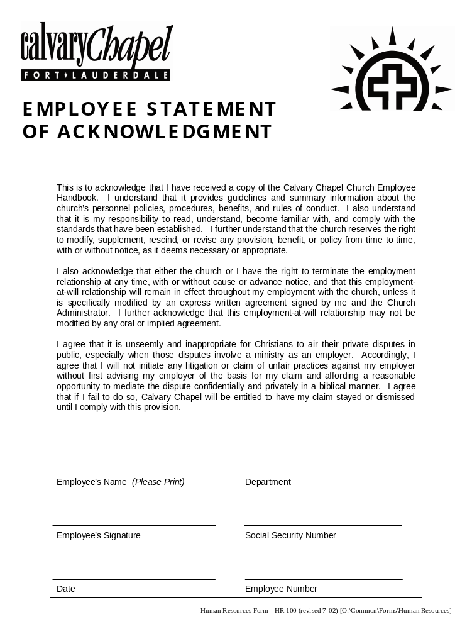

EXHIBIT B REQUEST FOR TIME OFF
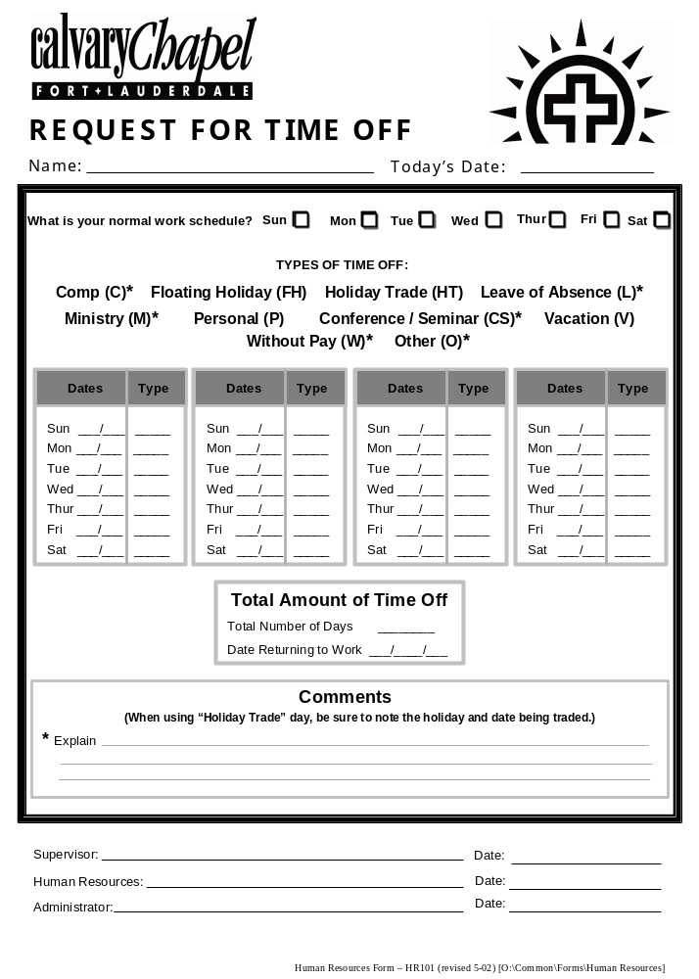
EXHIBIT C REQUEST FOR EMPLOYEE ABSENCE AND SUBSTITUTE ASSIGNMENT

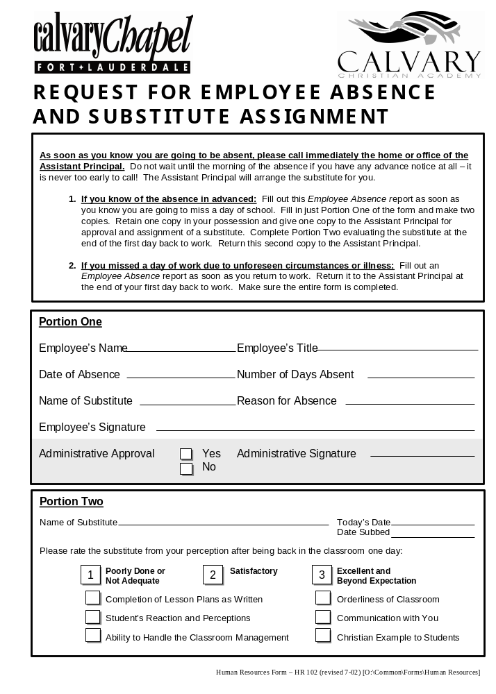
EXHIBIT D REQUEST FOR STAFF DEVELOPMENT

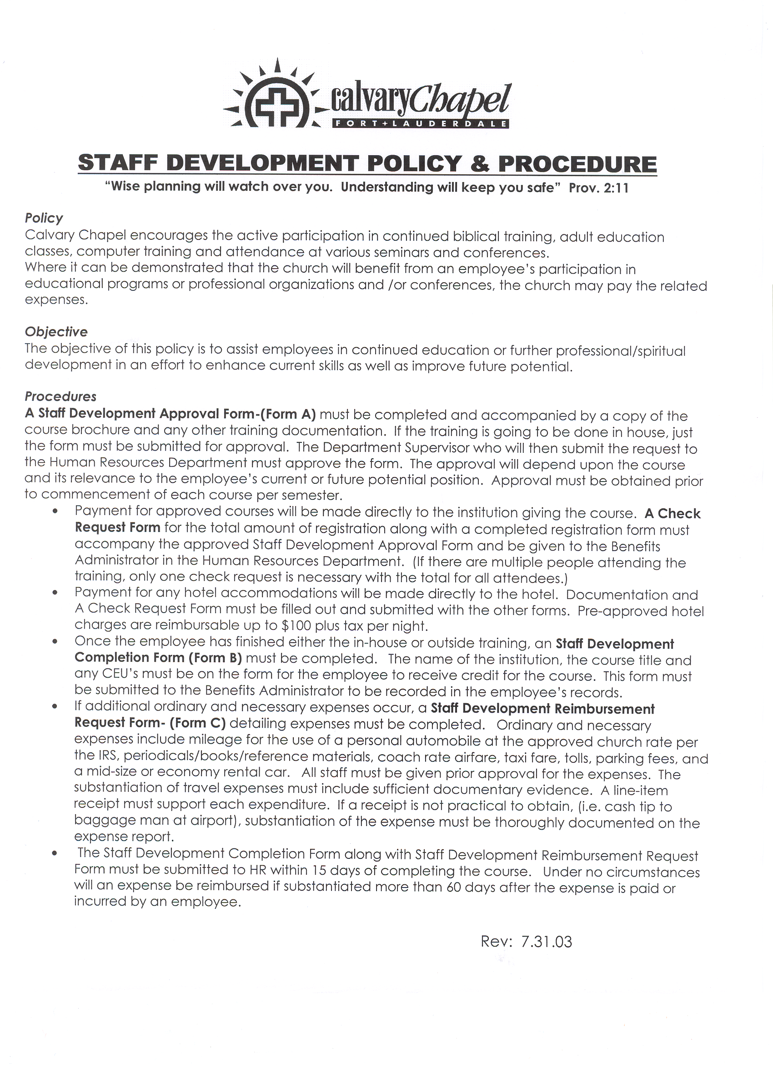

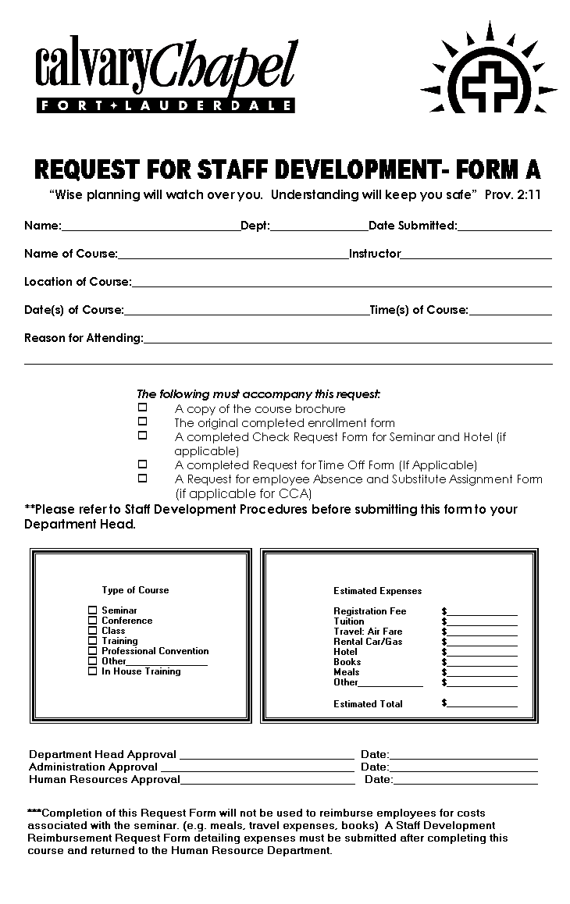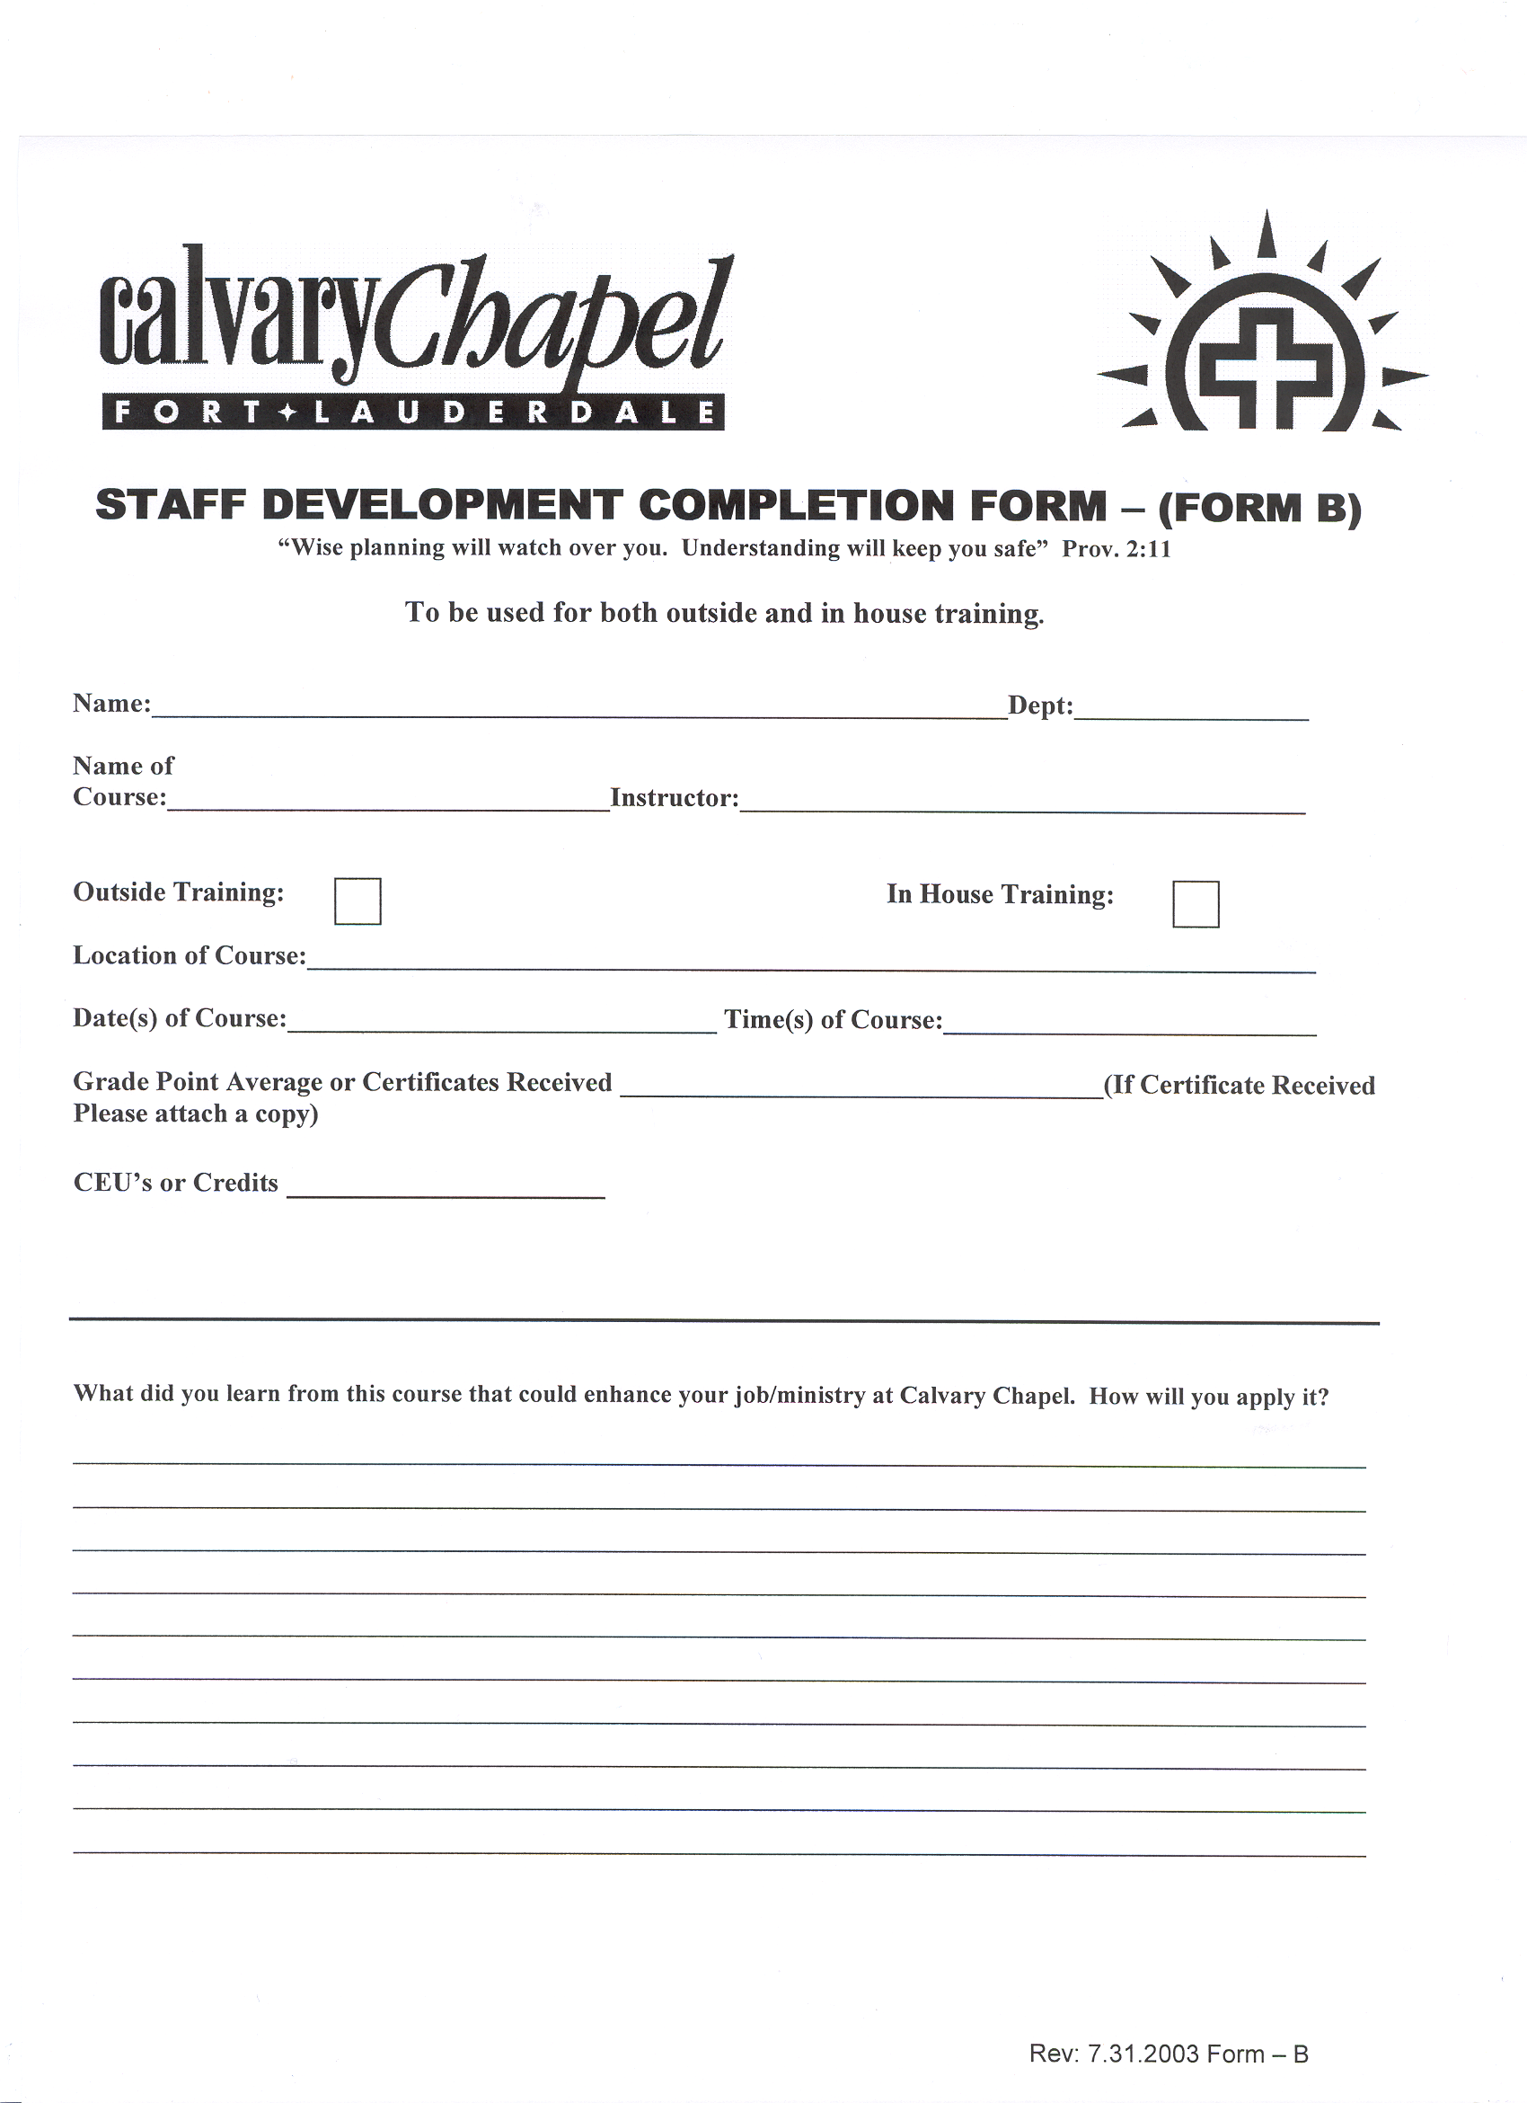

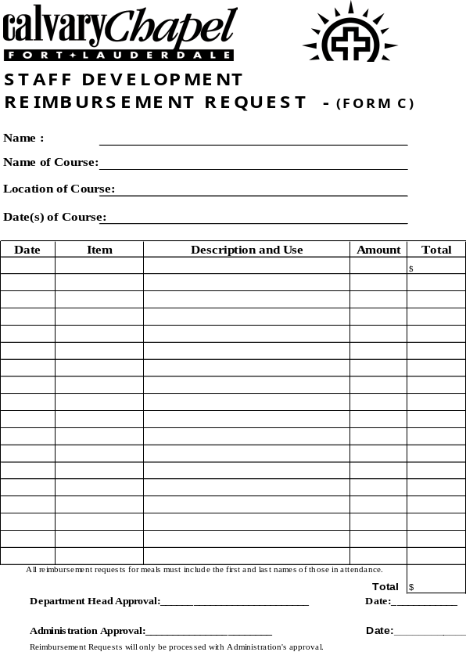

EXHIBIT E INCIDENT INJURY REPORT

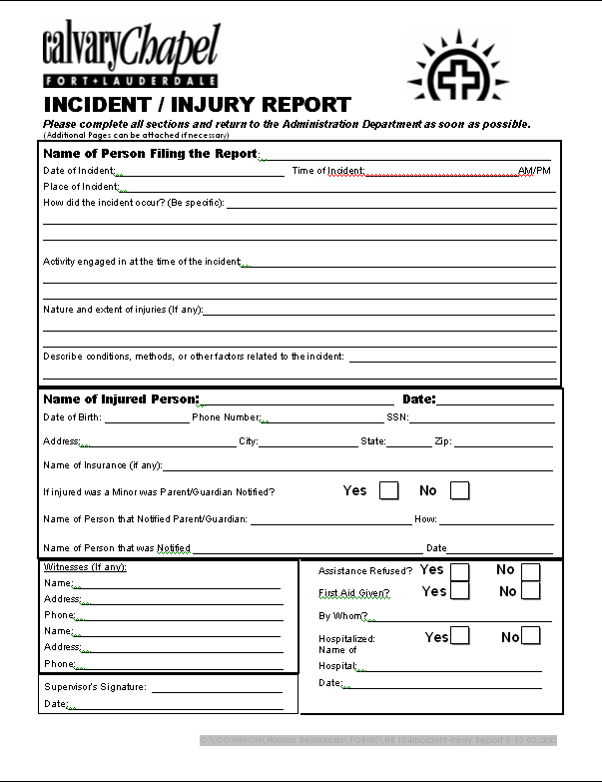
EXHIBIT F PERSONNEL MEMO

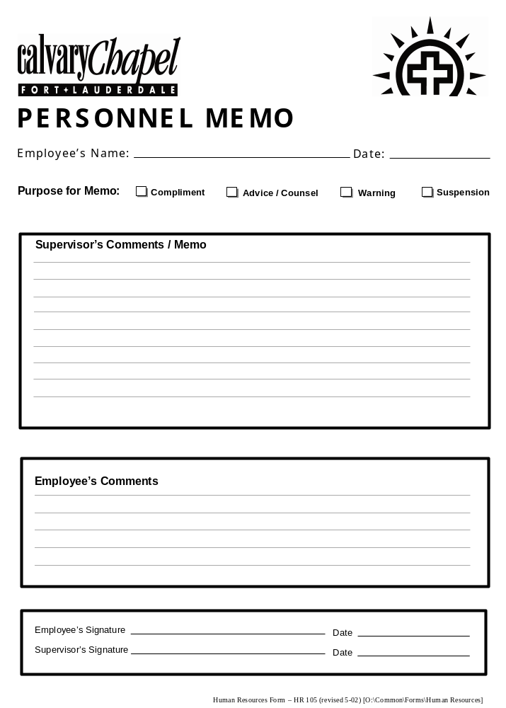
EXHIBIT G REQUEST FOR SCHEDULE CHANGE

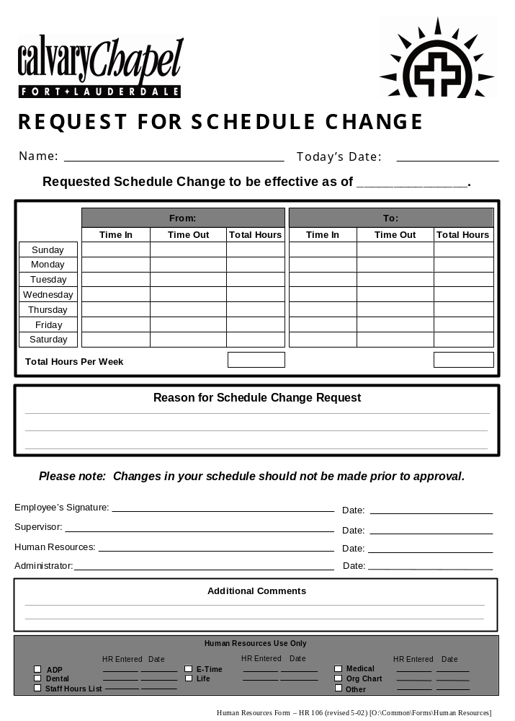
EXHIBIT H CHECK REQUEST FORM

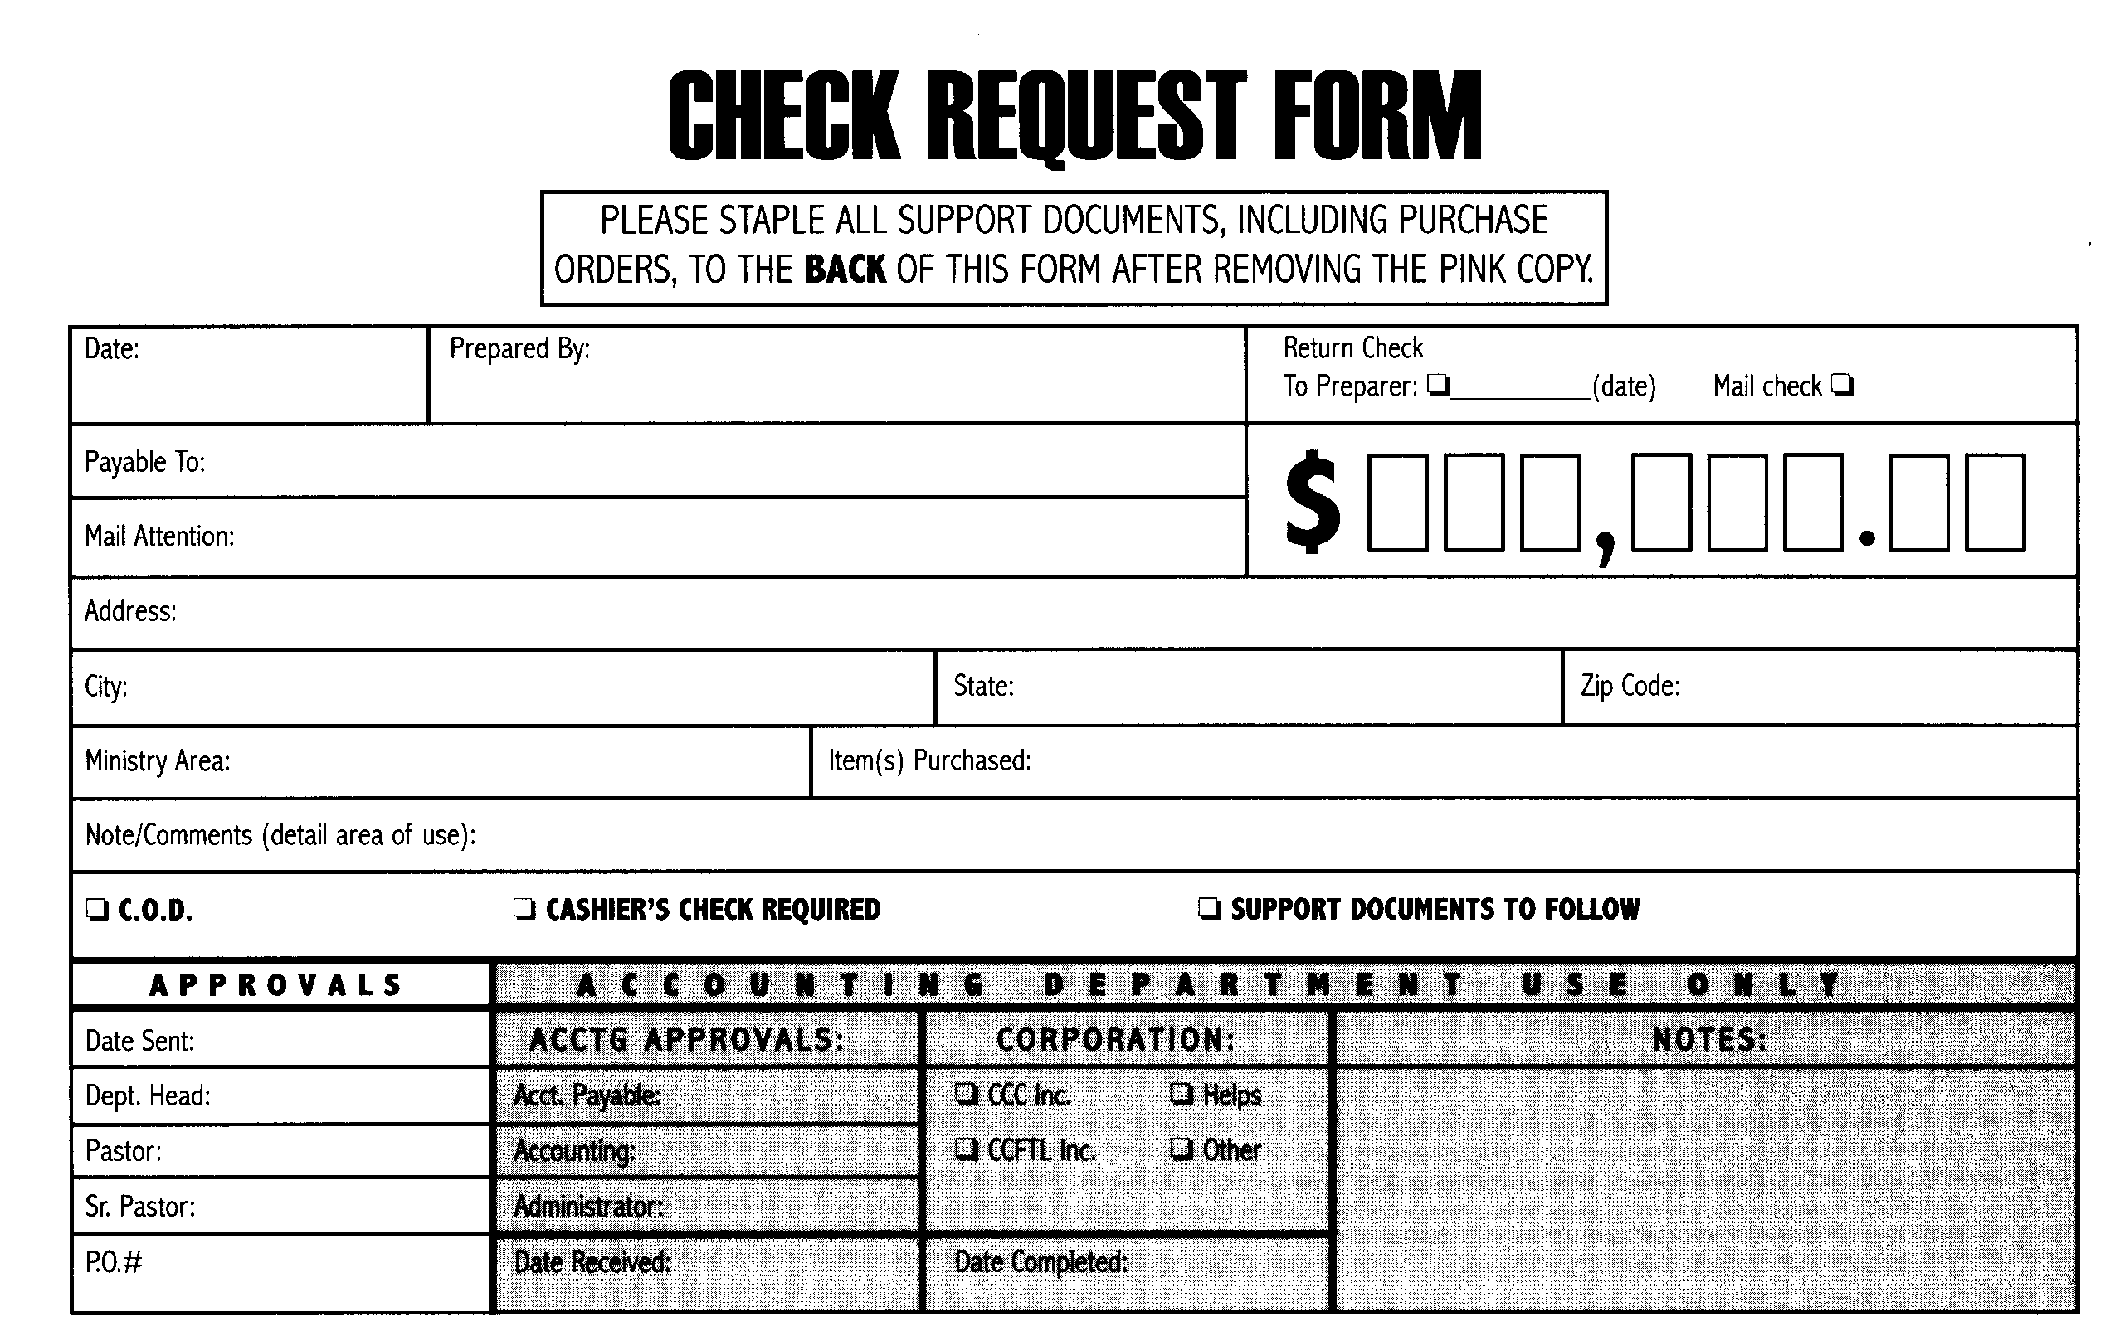

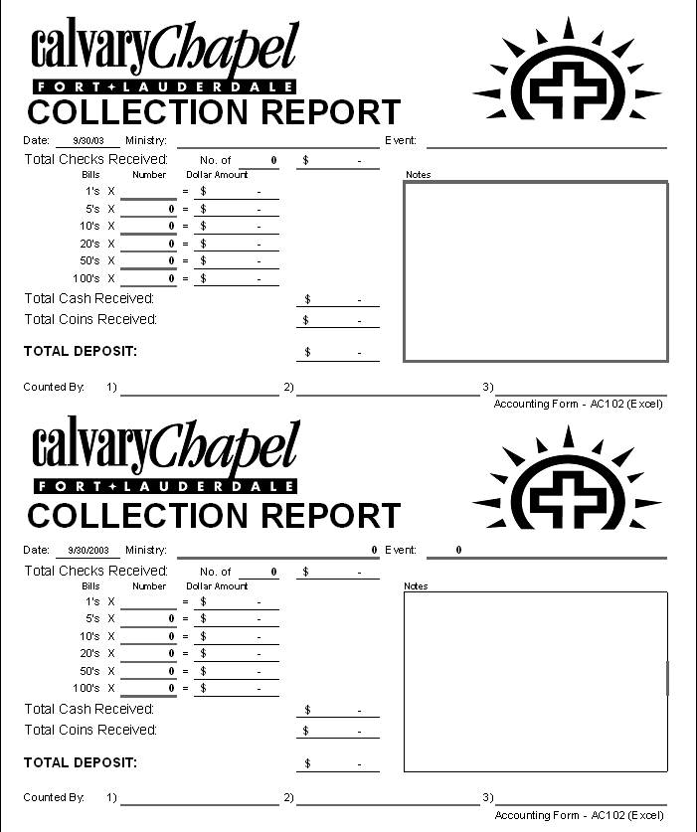
EXHIBIT I EMPLOYEE STATUS CHANGE



